Stage 6 PROMPT sheet | 6/2 Negative numbers  l l l l l l l  -3 -2 -1 0 1 2 3  2 > -2 We say 2 is bigger than -2  -2 < 2 We say -2 is less than 2 The difference between 2 and -2 = 4 (see line)  Remember the rules:  - When subtracting go down the number line  - When adding go up the number line  - 8 + - 2 is the same as 8 – 2 = 6  - 8 - + 2 is the same as 8 – 2 = 6  - 8 - - 2 is the same as 8 + 2 = 10
6/1 Place value in numbers to 10million
The position of the digit gives its size

Example
The value of the digit ‘1’ is 10 000 000
The value of the digit ‘2’ is 2 000 000
The value of the digit ‘3’ is 300 000
The value of the digit ‘4’ is 40 000
6/3 Multiply numbers & estimate to check
e.g. 152 x 34 COLUMN METHOD
152
34x
608 (x4)
4560 (x30)
5168
6/3 Use estimates to check calculations
152 x 34 ≈ is the
≈150 x 30 symbol for
≈4500 ‘roughly equals’
6/1 Round whole numbers

Example 1– Round 342 679 to the nearest 10 000
- Step 1 – Find the ‘round-off digit’ - 4
- Step 2 – Move one digit to the right - 2

- or less? YES – leave ‘round off digit’ unchanged
- Replace following digits with zeros ANSWER – 340 000
Example 2– Round 345 679 to the nearest 10 000
  - Step 1 – Find the ‘round-off digit’ - 4
  - Step 2 – Move one digit to the right - 5

- or more? YES – add one to ‘round off digit’
- Replace following digits with zeros ANSWER – 350 000
6/3 Divide numbers & estimate to check
With a remainder also expressed as a fraction

e.g. 4928 ÷ 32 BUS SHELTER METHOD
0 2 8 0 2 8 r 12
15 4 3 2 15 4⁴3¹³2
-3 0
1 3 2
-1 2 0
1 2
ANSWER - 432 ÷ 15 = 28 r 12
=2812
15
Ten millions | Millions | Hundred thousands | Ten thousands | thousands | hundreds | tens | ones
1 | 2 | 3 | 4 | 5 | 6 | 7 | 8

6/3 continued  With a remainder expressed as a decimal  0 2 8 . 8 0 2 8 . 8  15 4 3 2 . 0 15 4⁴3¹³2 .¹²0  -3 0  1 3 2  -1 2 0  1 2  ANSWER - 432 ÷ 15 = 28 . 8  6/3 Use estimates to check calculations  432 ÷ 15  ≈ 450 ÷ 15  ≈ 30 | e.g. 3 + 4 x 6 – 5 = 22  first (2 + 1) x 3 = 9  first
6/6 Addition
- Line up the digits in the correct columns

e.g. 48p + £2.84 + £9 0 . 4 8
2 . 8 4
9 . 0 0+
£1 2 . 3 2
1 1 1
6/6 Subtraction
- Line up the digits in the correct columns

e.g. 645 - 427 H T U 6 ³4 ¹5
4 2 7 -
2 1 8
6/4 Factors, multiples & primes
- FACTORS are what divides exactly into a number
e.g. Factors of 12 are: Factors of 18 are:
1 12 1 18
2 6 2 9
3 4 3 6

The common factors of 12 & 18 are: 1, 2, 3, 6, The Highest Common Factor is: 6
  - PRIME NUMBERS have only TWO factors
e.g. Factors of 7 are: Factors of 13 are
1 7 1 13

So 7 and 13 are both prime numbers
  - MULTIPLES are the times table answers
e.g. Multiples of 5 are: Multiples of 4 are:
5 10 15 20 25 ...... 4 8 12 16 20 .......

The Lowest Common Multiple of 5 and 4 is: 20
6/7 Equivalent fractions
- To simplify a fraction Example: 27
36
First find the highest common factor of the numerator and denominator – which is 9, then divide

27 ^{÷9} = 3
36 ÷9 4

- To change fractions to the same denominator

Example: 3 and 2
4 3

Find the highest common multiple of the denominators – which is 12, then multiply:
3x3 = 9 and 2^{x4} = 8 4 x3 12 3 x4 12
6/5 Order of operations Bracket
Indices Divide
Multiply Do these in the order they appear
Add Do these in the order they appear
Subtract

6/8 Add & subtract fractions  o Make the denominators the same  e.g. 1 + 7 e.g. 4 - 2  5 10 5 3  = 2 + 7 = 12 - 10  10 10 15 15  = 9 = 2  10 15 Do not add  denominators | - To multiply by 10, move each digit one place to the left  e.g. 35.6 x 10 = 356  Hundreds Tens Ones tenths  3 5 6  3 5 6  - To divide by 10, move each digit one place to the right  e.g. 35.6 ÷ 10 = 356= 3.56  Tens Ones tenths hundredths  3 5 6  3 5 6  - To multiply by 100, move each digit 2 places to the left  - To divide by 100, move each digit 2 places to the right  AN ALTERNATE METHOD  Instead of moving the digits  Move the decimal point the opposite way
6/9 Multiply fractions
5
- Write 5 as
1
- Multiply numerators & denominators
  - 5 x 2 e.g. 4 x 2
3 5 3
= 5 x 2 = 8
1 3 15
= 10 = 3 1
3 3

6/9 Divide fractions
5
    - Write 5 as
1
    - Invert the fraction after ÷ sign
    - Multiply numerators & denominators

e.g. 2 ÷ 5 e.g. 4 ÷ 2 3 5 3
= 3 x 1 = 4 x 3
2 5 5 2
= 3 = 12 = 1 2 = 1 1
10 10 10 5
6/11 Multiply decimals
Step 1 – remove the decimal point Step 2 – multiply the two numbers Step 3 – Put the decimal back in

Example: 0.06 x 8
=> 6 x 8
=> 48
=> 0.48

6/11 Divide decimals
Use the bus shelter method
Keep the decimal point in the same place Add zeros for remainders

Example: 6.28 ÷ 5
1 . 2 5 6
5 ) 6 . ¹2²8³0
6/10 Multiply/divide decimals by 10, 100
thousands | hundreds | tens | ones | . | tenths | hundredths | thousandths
4 | 3 | 5 | 2 | . | 6 | 1 | 7

6/12 Fraction, decimal, percentage equivalents  LEARN THESE:  1 = 0.25 = 25%  4  1 = 0.5 = 50%  2  3 = 0.75 = 75%  4  1 = 0.1 = 10%  10  - Percentage to decimal to fraction  27% = 0.27 = 27  100  7% = 0.07 = 7  100  70% = 0.7 = 70 = 7  100 10  - Decimal to percentage to fraction  0.3 = 30% = 3  10  0.03 = 3% = 3  100  0.39 = 39% = 39  100  - Fraction to decimal to percentage  4 = 80 = 80% = 0.8  5 100  Change to 100  0. 3 7 5  3 = 3 ÷ 8 = 8) 3.³0⁶0⁴0 = 0.375 = 37.5%  8  9 = 3 = 0.75 = 75%  12 4  Cancel by 3 | 6/13 Fraction of quantity  - 4 means ÷ 5 x 4 5  e.g. To find 4 of £40  5  £40 ÷ 5 x 4 = £40
6/13 Percentage of quantity
Use only
1
o 50% -
2
o 10% - 1
10
o 1% - 1
100

Example : To find 35% of £400 10% = £40
20% = £80
5% = £20
35% = £140
6/14 Similar shapes

When a shape is enlarged by a scale factor the two shapes are called SIMILAR shapes
5cm x2
3m

b 6m a

8cm
÷2

Scale factor = 6 ÷ 3 = 2 Length a = 5 x 2 = 10cm Length b = 8 ÷ 2 = 4cm
6/14 Unequal sharing
Example- unequal sharing of sweets
A gets B gets
3 shares 4 shares
=> 3 sweets x4 4 sweets x4
=> 12 sweets 16 sweets

6/15 Express missing numbers algebraically  An unknown number is given a letter  Examples  2a – 4 = 8 2a = 12 so a = 6  0  b 320 b + 32 = 180 so b = 148  30cm  18cm c  18 + c = 30 so c = 12  d d  d 3d = 360⁰ so d = 120⁰ | - Generate terms of a sequence  If the nth term is 5n + 1 1st term (n=1) = 5x1 + 1 = 6 2nd term (n=2) = 5x2 + 1= 11 3rd term (n=3) = 5x3 + 1 = 16
6/17 Possible solutions of a number sentence

Example: x and y are numbers Rule: x + y = 5
Possible solutions: x = 0 and y = 5
x = 1 and y = 4 x = 2 and y = 3 x = 3 and y = 2 x = 4 and y = 1 x = 5 and y = 0
6/18 Convert units of measure
METRIC
When converting measurements follow these rules:
- When converting from a larger unit to a smaller
unit we multiply (x)
- When converting from a smaller unit to a larger
unit we divide (÷)

UNITS of LENGTH
10mm = 1cm 100cm = 1m
1000m = 1km UNITS of TIME
UNITS of MASS 60sec = 1 min
1000g = 1kg 60min = 1 hour
1000kg = 1tonne 24h = 1 day 365days = 1 year
UNITS of VOLUME
1000ml = 1 litre 100cl = 1litre
6/15 Use a word formula

Example: -Time to cook a turkey Cook for 45min per kg weight Then a further 45min

For a 6kg turkey, follow the formula: 45min x 6 + 45min
=270min + 45min
=315min
= 5h 15min
6/16 Number sequences
- Understand position and term

+4
Term to term rule = +4 Position to term rule is x 4 - 1 (because position 1 x 4 – 1 = 3)
nth term = n x 4 -1 = 4n - 1
6/19 Convert units of measure
METRIC/IMPERIAL

LEARN: 5 miles = 8km

Miles ÷ 5 x8 kilometres

Miles x 5 ÷8 kilometres
Position | 1 | 2 | 3 | 4
Term | 3 | 7 | 11 | 15

6/20 Perimeter and area of shapes  Shapes can have the SAME area but different perimeters  The area of each shape is 9 squares  Perimeter of each shape is different A – 12; B – 14; C -16 | 6/23 Construct 2D shapes  Example : Triangle with side and angles given  - Draw line AB = 7cm  - Draw angle 34⁰ at point A from line AB  - Draw angle 47⁰ at point B from line AB  - Extend to intersect the lines at C  C  0 0  A 34 47 B  7cm
6/23 Construct 3D shapes
CUBE & its net

CUBOID & its net

TRIANGULAR PRISM & its net
6/21 Area of parallelogram & triangle
- Area of parallelogram
Area of parallelogram = b x h 5cm
= 8 x 5
= 40cm² 8cm

- Area of triangle (½ a parallelogram)
Area of triangle = b x h
2
= 8 x 5 5cm
2
20cm²
8cm
6/22 Volume
- Volume of cuboid
Volume = l x w x h
= 5 x 3 x 2
= 30cm³ 3cm
2cm
5cm
- Volume of cube
Volume = l x w x h
= 3 x 3 x 3
= 27m³ 3m
3m
3m
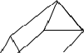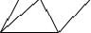
B
A
C

6/24 Properties of shapes  TRIANGLES – sum of angles = 180⁰  ISOSCELES triangle  - equal sides & 2 equal angles  EQUILATERAL triangle  - equal sides & ALL angles 60⁰  SCALENE triangle  All sides & angles different  QUADRILATERALS – sum of angles = 360⁰  Square rectangle parallelogram  Rhombus trapezium kite  REGULAR POLGONS – all sides the same  - Polygons have straight sides  - Polygons are named by the number sides 3 sides – triangle  4 sides – quadrilateral 5 sides – pentagon  6 sides – hexagon 7 sides – heptagon 8 sides – octagon 9 sides – nonagon 10 sides – decagon | - Sum of exterior angles is always 360⁰  108⁰ 72⁰  - interior & exterior angle add up to 180⁰  - the interior angles add up to: Triangle =1 x 180⁰ = 180⁰ Quadrilateral =2 x 180⁰ = 360⁰  Pentagon =3 x 180⁰ = 540⁰  Hexagon =4 x 180⁰ = 720⁰ etc
6/25 Parts of a circle
- The circumference is the distance all the way around a circle.
- The diameter is the distance right across the middle of the circle, passing through the centre.
- The radius is the distance halfway across the circle.
- The radius is always half the length of the diameter. (d = 2 x r) or (r = ½ x d)

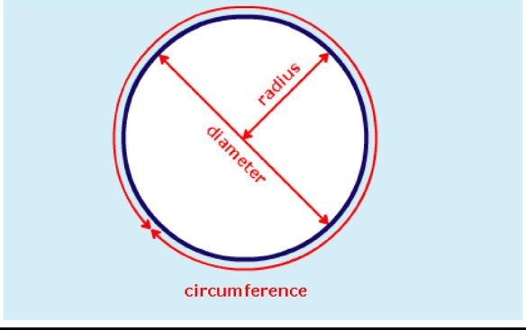

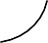

6/26 Angles and straight lines

o Angles on a straight line add up to 180⁰

148⁰ 32⁰

148⁰ + 32⁰ = 180⁰

o Angles about a point add up to 360⁰
146⁰
124⁰

146⁰ + 90⁰ + 124⁰ = 360⁰

- Vertically opposite angles are equal
146⁰
34⁰
34⁰
146⁰

6/28 Transformations
- Translation -A shape moved along a line

Example – Move shape A 3 right & 4 down
Can also be written as a vector 3 Right
-4 Down
A
B
Notice:
- The new shape stays the same way up
- The new shape is the same size

Reflect a shape in x-axis

6/27 Position on a co-ordinate grid

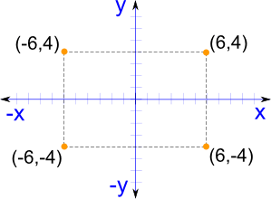
o Reflect a shape in y-axis

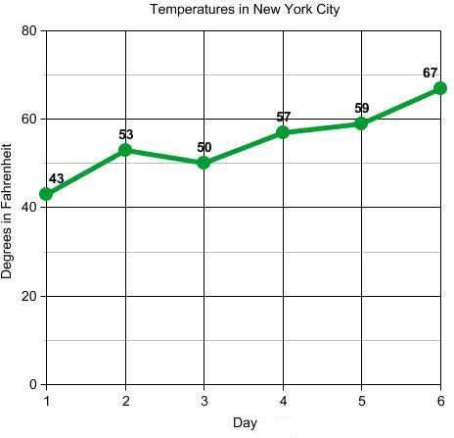6/29 Graphs

Pie chart

Transport | Frequency | Angle
Car | 13 | 13 x 9=117⁰
Bus | 4 | 4 x 9=36⁰
Walk | 15 | 15 x 9=135
Cycle | 8 | 8 x 9=72

Total frequency = 40
360⁰ ÷ 40 = 9⁰ per person

car bus walk cycle

Line graph
Line graphs show changes in a single variable – in this graph changes in temperature can be observed.

6/30 The mean
The mean is usually known as the average. The mean is not a value from the original list.
It is a typical value of a set of data
Mean = total of measures ÷ no. of measures
e.g.- Find mean speed of 6 cars travelling on a road Car 1 – 66mph
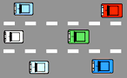
Car 2 – 57mph Car 3 – 71mph Car 4 – 54mph Car 5 – 69mph Car 6 – 58mph

Mean = 66+57+71+54+69+58
6
= 375
6
= 62.5mph
Mean average speed was 62.5mph

