Stage 5 PROMPT sheet | 5/3 Negative numbers  A number line is very useful for negative numbers.  - The number line below shows:  4 – 7 = -3  l l l l l l l l l  -3 -2 -1 0 1 2 3 4 5  - The number line below shows:  -2 + 6 = 4  l l l l l l l l l  -3 -2 -1 0 1 2 3 4 5
5/1 Place value in numbers to 1million
The position of the digit gives its size

Example
The value of the digit ‘1’ is 1 000 000
The value of the digit ‘2’ is 200 000
The value of the digit ‘3’ is 30 000 The value of the digit ‘4’ is 4000
5/4 Roman Numerals
The seven main symbols I = 1
V = 5
X = 10 Other useful ones include: L = 50 IV = 4
C = 100 IX = 9
D = 500 XL = 40
M = 1000 XC = 90
5/2 Round numbers to nearest 10, 100, 1000, 10000, 100000
Example 1– Round 342 679 to the nearest 10 000
- Step 1 – Find the ‘round-off digit’ - 4
- Step 2 – Look one digit to the right of 4 - 2

5 or more? NO – leave ‘round off digit’ unchanged
- Replace following digits with zeros ANSWER – 340 000
Example 2– Round 453 679 to the nearest 100 000
- Step 1 – Find the ‘round-off digit’ - 4
- Step 2 – Look one digit to the right - 5

5 or more? YES – add one to ‘round off digit’
- Replace following digits with zeros ANSWER – 500 000
5/5 Written methods for addition
- Line up the digits in the correct columns
- Start from RIGHT to LEFT
e.g. 48 + 284 + 9 H T U 4 8
2 8 4
₁ ₂ 9 +
3 4 1
5/5 Written methods for subtraction
- Line up the digits in the correct columns
- Start from RIGHT to LEFT
e.g. 645 - 427 H T U 6 ³4 ¹5
4 2 7 -
2 1 8
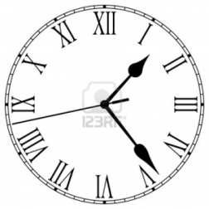
Millions | Hundred thousands | Ten thousands | thousands | hundreds | tens | ones
1 | 2 | 3 | 4 | 5 | 6 | 7

5/6 Mental methods for addition  - Start from LEFT to RIGHT  Example 1 – think of:  45 + 32 as 45 + 30 + 2  - But in your head say:  45 75 77  Example 2 – think of:  1236 + 415 as 1236 + 400 + 10 + 5  - But in your head say:  1236 1636 1646 1651  5/6 Mental methods for subtraction  Example 1 – think of:  56 – 32 as 56 – 30 – 2  - But in your head say:  56 26 24  Example 2 – think of:  1236 - 415 as 1236 - 400 - 10 - 5  - But in your head say:  1236 836 826 821 | 5/8 Multiples & factors  - FACTORS are what divides exactly into a number  e.g. Factors of 12 are: Factors of 18 are:  1 12 1 18  2 6 2 9  3 4 3 6  The common factors of 12 & 18 are: 1, 2, 3, 6, The Highest Common Factor is: 6  - MULTIPLES are the times table answers  e.g. Multiples of 5 are: Multiples of 4 are:  5 10 15 20 25 ...... 4 8 12 16 20 .......  The Lowest Common Multiple of 5 and 4 is: 20
5/9 Prime numbers
Prime numbers have only TWO factors

The factors of 12 are: Factors of 7 are:
1, 2, 3, 4, 6, 12 1, 7

12 is NOT prime 7 IS prime It is composite

Prime numbers to 20

The number ‘1’ is NOT prime

It has only ONE factor
5/7 Multi-step problems

Based upon 5/6.
Words associated with addition:
sum total

add altogether

Words associated with subtraction:

Subtract difference
minus

How many more?
1 | 2 | 3 | 4 | 5
6 | 7 | 8 | 9 | 10
11 | 12 | 13 | 14 | 15
16 | 17 | 18 | 19 | 20

5/10 Multiplication using a formal method

- By a ONE-DIGIT number

e.g. 3561 x 7 COLUMN METHOD
3561
7x
24927
3 4

e.g. 3561 x 7 GRID METHOD

 | 3000 | 500 | 60 | 7
7 | 21000 | 3500 | 420 | 49

21000 + 3500 + 420 + 49 = 24927

5/10 Division using a formal method

  - By a ONE-DIGIT number

e.g. 9138 ÷ 6 1 5 2 6
6 )9³1¹3¹8

By a TWO-DIGIT number

e.g. 4928 ÷ 32 SAME METHOD
(Except write down some of your tables down first) 32
64 0 1 5 4
96 32 4⁴9¹⁷2 ¹²8
128
160

4928 ÷ 32 = 154

By a TWO-DIGIT number

e.g. 152 x 34 COLUMN METHOD
152
34x
608 (x4)
4560 (x30)

5168

e.g. 152 x 34 GRID METHOD

e.g. 4928 ÷ 32 ALTERNATE METHOD
  - Divide
  - Multiply
  - Subtract
  - Bring down - Make a new number
  - Divide ...
0 1 5 4
32 4 9 2 8
-3 2
1 7 2
-1 6 0
1 2 8
-1 2 8
0 0 0
 | 100 | 50 | 2
30 | 3000 | 1500 | 60
4 | 400 | 200 | 8

4928 ÷ 32 = 154

152 x 34 = 3400 + 1700 + 68 = 5168

5/11 Multiply & divide by 10, 100, 1000  - By moving the decimal point  To multiply by 10 move the dp ONE place RIGHT  e.g. 13 X 10 = 130  3.4 x 10 = 34  To divide by 10 move the dp ONE place LEFT  e.g. 1 3 ÷ 10 = 1.3  3.4 ÷ 10 = 0.34  - By moving the digits  To multiply by 10 move the digits ONE place LEFT  e.g. 3.52 x 10  = 3 5 . 2  To multiply or divide by 100 move TWO places To multiply or divide by 1000 move THREE places | Cube numbers  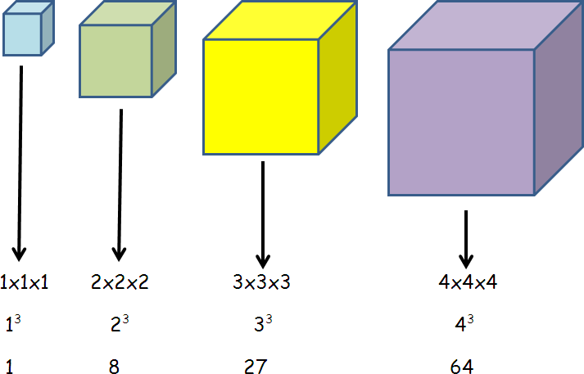
5/13 Fractions

- To compare fractions
– the denominators must be the same

2 5
3 and 6
4 5
6 and 6
5 2
SO 6 is bigger than 3

- To add and subtract fractions
When the denominators are the same
5 1 6 Do not add

8 + 8 = 8 the denominators

5 1 4 Do not subtract

8 - 8 = 8 the denominators
5/12 Square & Cube numbers

Square numbers
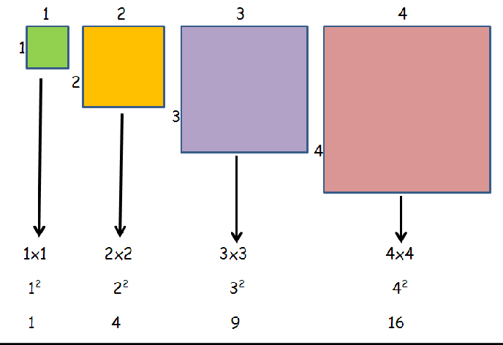




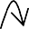

5/13 To add subtract fractions (cont) When the denominators are different  3 1(x2)  8 + 4(x2)  Multiply to make  the denominators  3 2 5 the same  8 ⁺ 8 ⁼ 8 | - A mixed number can be changed back into an improper fraction  1½ = ³  2  2¾ = ¹¹  4
5/14 Equivalent fractions
These fractions are the same but can be drawn and written in different ways

=

3 12

4 = 16
3 (x4) 12
4 (x4) = 16
Fractions can also be divided to make the fraction look simpler – this is called CANCELLING or LOWEST FORM

12 (÷4) 3
16 (÷4) = 4
5/16 Multiply fractions

Multiply is the same as repeated addition

+ +

3 3 3

4 + 4 + 4

3 3 3 3 9 1
4 x 3 = 4 + 4 + 4 = 4 = 2 4
OR

3 3 9 1
4 x 1 = 4 = 2 4
5/15 Mixed & improper fractions
- An improper fraction is top heavy
& can be changed into a mixed number

3 can be shown in a diagram
2

1 ½
3 = 1½
2

Improper fraction Mixed number


5/17 Round decimals

Rules for rounding

Find the ‘round off’ digit
- Move one digit to its right

Is this digit 5 or more
Yes – add one to the round off digit No – don’t change the round off digit

To the nearest whole number

e.g. 1 – To round 5.62 to the nearest whole

‘round off’ digit this digit is 5 or more

5.62 rounded to nearest whole = 6

e.g. 2 – To round 5.32 to the nearest whole

‘round off’ digit this digit is NOT 5 or more

5.32 rounded to nearest whole = 5

To one decimal place

e.g. 1 – To round 12.37 to 1 decimal place

‘round off’ digit this digit is 5 or more

12.37 rounded to 1dp = 12.4

e.g. 2 – To round 12.32 to the nearest whole

‘round off’ digit this digit is NOT 5or more

12.37 rounded to 1dp = 12.3

5/18 Read & write decimals
The value of each digit is shown in the table
hundreds | tens | ones |  | tenths | hundredths | thousandths
3 | 5 | 2 |  | 6 | 1 | 7
300 | 50 | 2 |  | 6  10 | 1  100 | 7  1000
352 |  |  |  | 61  100 |  | 7  1000
352 |  |  |  | 617  1000

5/18 Order decimals

Example – To order 0.28, 0.3, 0.216
  - Write them under each other

Fill gaps with zeros
  - Then order them
•
0.28 0.280
0.3 0.300
0.216 0.216

smallest largest
Order: 0.216 0.28 0.3

5/19 Decimal & Percentage equivalents Learn
Fraction | Decimal | Percentage
1  2 | 0.5 | 50%
1  4 | 0.25 | 25%
1  5 | 0.2 | 20%
1  10 | 0.1 | 10%
1  100 | 0.01 | 1%
Some fractions have to be changed to be ‘out of 100’

5/20 Imperial measure

  - 1 inch is about 2.5cm

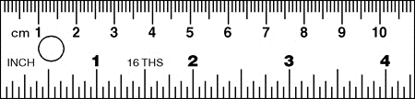

  - 1km = 1.6 miles or 5miles = 8km

11 (x4) =
25 (x4)
44 = 0.44 = 44%
100
- 1kg is about 2.2pounds

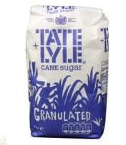
5/20 Convert metric measure
  - Length
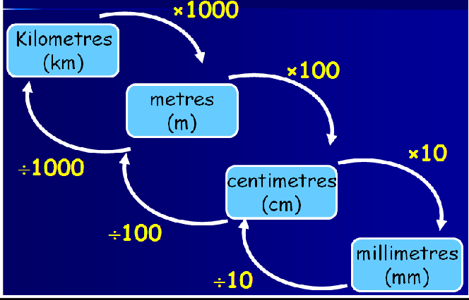

Mass or weight

kilograms (kg)
x1000
÷1000
grams (g)
  - Capacity or volume

- A litres of water’s a pint and three quarters

- A gallon is about 4.5 litres

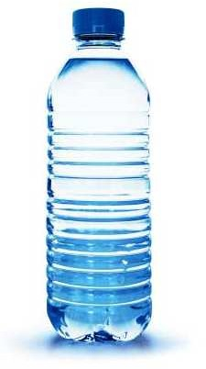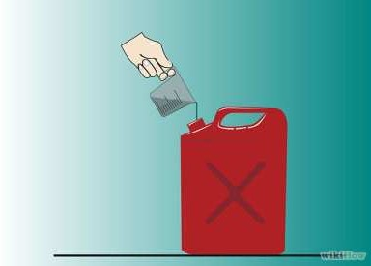
litres (l)
x1000

millilitres (ml)
÷1000

5/21 Area & Perimeter  - Estimate area  Number of whole squares( ) = 16 Number of ½ or more ( ) = 5 Estimated area = 21 squares  - Shapes composed of rectangles  Put on all missing lengths first  For perimeter – ADD all lengths round outside  For area - split into rectangles & add them together  12cm  4cm 6cm  8cm  12cm  4cm 6cm  8cm  2cm  4cm  Perimeter = 12 + 6 + 4 + 2 + 8 + 4 = 36cm  12cm  4cm A B 6cm 8cm  2cm  4cm  Area of shape = Area of A + B  = (8x4) + (6x4)  = 32 + 24  = 56cm² | 5/22 Volume  Volume is measured in cubes  The 1 cm cube  1cm  1cm The volume of this cube is 1 cm³ 1cm I (1 cubic centimetre) r  t holds 1ml of wate  This cuboid contains 12 cubes So the volume is 12 cm³  This 3D shape contains 12 cubes So the volume is 12 cm³
5/23 Units of time
- Time conversion

x365
year
x24
days
÷365 x60
hours
÷24 x60
min
÷60
sec
÷60
- Time intervals
Always go to the next whole hour first

Example: 0830 to 1125
30min + 2h 25min = 2h 55min 0830 0900 1125
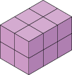

5/24 2D representations of 3D shapes  - There are 3 views:  Plan view  Side elevation  Front elevation | 5/26 Angles  Angles on a straight line add up to 180⁰ or 2 right angles (2 x 90⁰)  Angles about a point add up to 360⁰ or 4 right angles (4 x 90⁰)
5/25 Angles
- Types of angles
Acute Obtuse
(less than 90⁰) (Between 90⁰ & 180⁰)



Reflex
(Between 180⁰ & 360⁰)

- Measure and draw angles

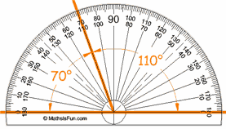
To be sure, count the number of degrees between the two arms of the angle
5/27 Properties of the rectangle

- A rectangle is a quadrilateral (4 sided shape)
- All angles are 90⁰

- Opposite sides are equal

- Opposite sides are parallel

- Diagonals are equal

- Diagonals bisect each other (cut in half)

- A square is a special rectangle

5/28 Reflection
  - Reflection in a vertical line

5/29 Line graphs

  - Find the difference

Example 1 : What was the difference in temperature between 1030 and 1130?
Answer: 11.5⁰C – 10⁰C = 1.5⁰C

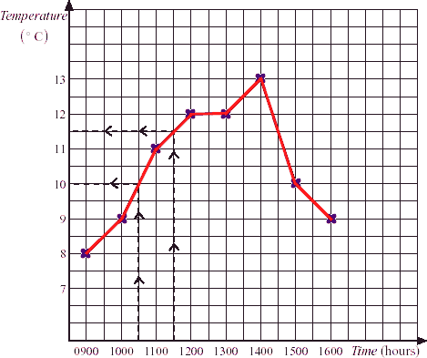

Reflection in a horizontal line

    - Find the sum of the data

Example: What was the total number of days absent over the 6 years?
Answer: 3 + 4 + 7 + 7 + 9 + 2 = 32 days

10

5/28 Translation – 4 right & 1 down 8
Days absent
6
4
2
0
Year 1 Year 2 Year 3 Year 4 Year 5 Year 6

  - In reflection and translation the shapes remain the same size and shape – CONGRUENT
  - In reflection the shape is flipped over
  - In translation the shape stays the same way up

5/30 Interpret information in tables

Distance table
Example: Find the distance between Leeds and York
Answer: 40miles

Hull
100 | Leeds
162 | 73 | Manchester
110 | 60 | 65 | Sheffield
63 | 40 | 118 | 95 | York

Timetable
Example: How long is the film? Answer: 1.10 – 2.35 = 1h 25min = 85min

6.30am | Educational programme
7.00 | Cartoons
7.25 | News and weather
8.00 | Wildlife programme
9.00 | Children's programme
11.30 | Music programme
12.30pm | Sports programme
1.00 | News and weather
1.10 - 2.35pm | Film

  - Table of results of goals scored Example: Did boys or girls score the most goals? Answer: Boys: 6+3+3+6=18
Girls: 7+5=12
Boys scored the most goals


