Year 4

4/1 Count in multiples
Now you must learn these multiples

Multiples of 6 | Multiples of 7 | Multiples of 9 | Multiples of 25
6 | 7 | 9 | 25
12 | 14 | 18 | 50
18 | 21 | 27 | 75
24 | 28 | 36 | 100
30 | 35 | 45 | 125
36 | 42 | 54 | 150
42 | 49 | 63 | 175
48 | 56 | 72 | 200
54 | 63 | 81 | 225
60 | 70 | 90 | 250

4/2 Find 1000 more or less

thousands | hundreds | tens | ones
4 | 5 | 6 | 7

To increase or decrease by 1000 this is the digit that changes.

4/2 Round to nearest 10, 100, 1000,

Example 1– Round 4279 to the nearest 1000
- Step 1 – Find the ‘round-off digit’ - 4
- Step 2 – Look one digit to the right of 4 - 2

5 or more? NO – leave ‘round off digit’ unchanged
- Replace following digits with zeros ANSWER – 4000
Example 2– Round 4279 to the nearest 10
- Step 1 – Find the ‘round-off digit’ - 7
- Step 2 – Look one digit to the right of 7 - 9

5 or more? YES – Add one to the ‘round off digit’
- Replace following digits with zeros ANSWER – 4280

4/3 Negative numbers

Negative numbers are numbers BELOW ZERO

Think of a number line

- Horizontal number line


- Vertical number line

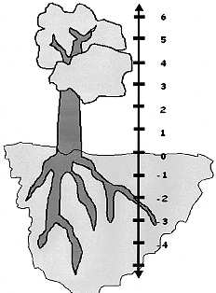
Positive numbers
4567 has decreased
by 1000 to 3567
4567 has increased
by 1000 to 5567
thousands | hundreds | tens | ones
5 | 5 | 6 | 7

thousands | hundreds | tens | ones
3 | 5 | 6 | 7

Negative numbers

4/4 Place value  3000  700  40  8 | 4/6 Add & subtract  - Line up digits from right to left  Example 1: Add 4735 and 386  4 7 3 5 4 7 3 5  3 8 6 + ₁ 3₁ 8₁ 6 +  5 1 2 1 5 1 2 1  1 1 1  Example 2: Subtract 637 from 2476  2¹ ¹4 7⁶ ¹6 2 ¹4 7 ¹6  6 3 7 - ₁ 6 3₁ 7 -  1 8 3 9 1 8 3 9
4/5 Roman Numerals to 100
The numbers 1-100 are constructed from these:

I = 1
V = 5
X = 10
L = 50
C = 100

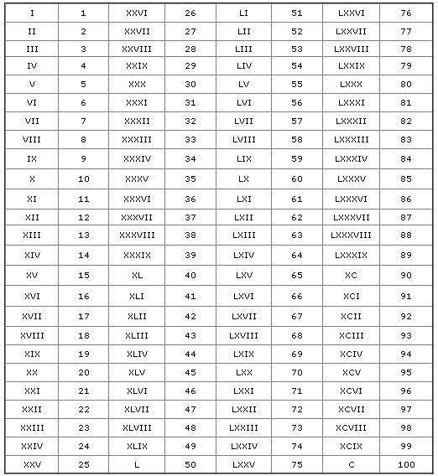

4/7 Estimate a calculation
- Round off each number so that the calculation is easy to do
Example 1: 644 x 11 To make it easy use:
600x11=6600 or 600x10 =6000

Example 2: 503.926 + 709.328
To make it easy use:
500 + 700 = 1200

Example 3: Half of 51.4328963 To make it easy use:
Half of 50 = 25

Example 3: 806 - 209 To make it easy use:
800 – 200 = 600
4/8 Addition & subtraction problems (Based upon 4/6)
Words associated with addition:
sum total
add altogether
Words associated with subtraction:

Subtract difference
minus

How many more?

thousands | hundreds | tens | ones
3 | 7 | 4 | 8

4/9 Multiplication tables
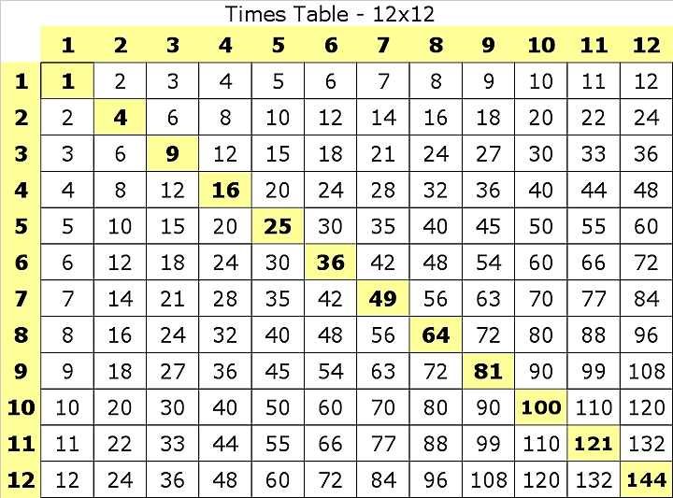
Remember:
7 x 8 = 56 8 x 7 = 56 56 ÷ 7 = 8 56 ÷ 8 = 7

4/10 Factor pairs
Example: We know 342 x 7 = 2394 (See above)

x2 x2
So we also know 684 x 7 = 4788

Example: We know 342 x 7 = 2394 (See above)

+1
So we also know 342 x 8 = 2394 + (342 x 1)
= 2736

4/13 Common equivalent fractions
- The same fraction can be expressed in different ways
ALL THESE ARE 1

2

The number 12 can be made from these factor pairs

1 x 12
From these factor pairs we can see that the factors of 12 are: 1, 2, 3,
4, 6, 12
- x 6
- x 4
- x 3
6 x 2
12 x 1

4/11 Multiply by a single digit number

Example: 342 x 7
1 = 2 =

2 4

ALL THESE ARE 3

4

3 = 6 =

4 8
3 = 8

6 16

9 = 18
12 24

4/14 Hundredths
3 4 2 | 3 4 2 | 300 x 7 = 2100
7 x | 2 1 7 x | 40 x 7 = 280
2 3 9 4  2 1 | 2 3 9 4 | 2 x 7 = 14  342 x 7 = 2394

tens | ones | . | tenths | hundredths
8 | 2 |  | 6 | 4

4/12 Connections between 2 calculations
Look for connections between the 2 calculations
Example: We know 342 x 7 = 2394 (See above)

- This represents 4 hundredths =

4

100

So we also know 342 x 14 = 4788
x2
x2
- To find a hundredth of an object or quantity you divide by 100

4/14 Counting in hundredths (continued)  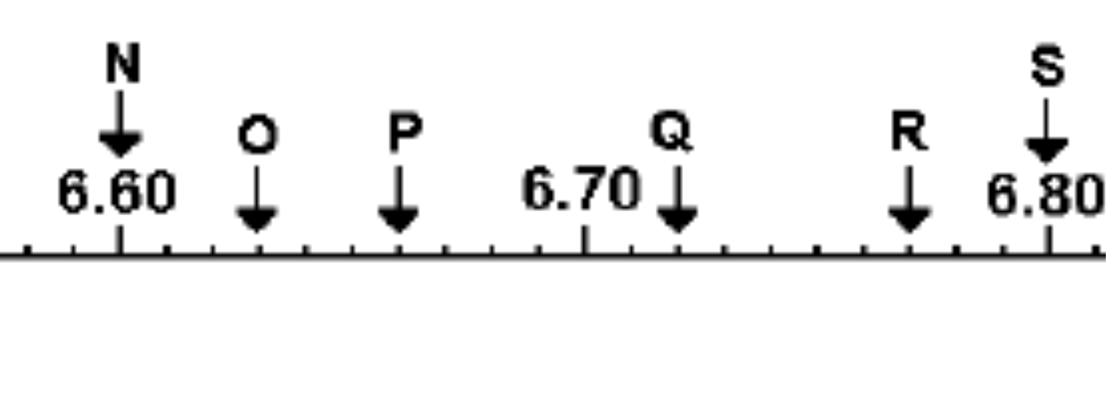  O = 6.63  P = 6.66  Q = 6.72  R = 6.77 | 4/16 Decimal equivalents  Others to learn are:  1 = 0.25 1 = 0.5 3 = 0.75  4 2 4
4/17 Effect of dividing by 10 and 100
- To divide by 10, move each digit one place to the right

e.g. 35 ÷ 10 = 3.5

Tens | Ones |  | tenths
3 | 5
 | 3 |  | 5

- To divide by 100, move each digit 2 places to the right

e.g. 35 ÷ 100 = 0.35
(we add a zero to show there are no whole numbers)

4/15 Add & subtract fractions

- To add and subtract fractions
When the denominators are the same
5 3 8 Do not add
8 + 8 = 8 = 1 the denominators
5 1 4 Do not subtract
8 - 8 = 8 the denominators
4/16 Decimal equivalents

0.6 ⬄ 6
10

0.03 ⬄ 3
100

0.63 ⬄ 63
100
4/18 Round decimals to nearest whole
The Rules:

- If the digit behind the decimal point is LESS THAN 5, the number is rounded DOWN to the next whole number
Example: 6.4 becomes rounded to 6

- If the digit behind the decimal point is 5 OR MORE, the number is rounded UP to the next whole number
Example: 6.5 becomes rounded to 7
6.8 becomes rounded to 7
Tens | Ones |  | tenths | hundredths
3 | 5
 | 0 |  | 3 | 5

ones |  | tenth s
0 |  | 6

ones |  | tenths | hundredths
0 |  | 0 | 3

ones |  | tenths | hundredths
0 |  | 6 | 3

4/19 Convert between units of measure  - Time  x12  year  x4  months  ÷12 X7  weeks  ÷4  days  ÷7  x60  hours  min  ÷60  sec  ÷60  - Length  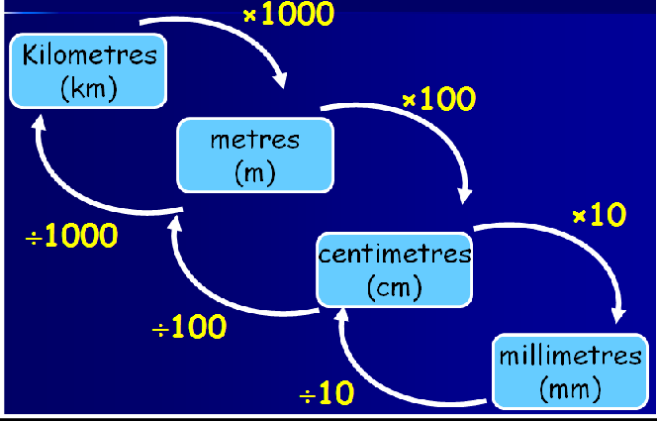  - Mass or weight  kilograms x1000  (kg)  grams  ÷1000 (g)  - Capacity or volume  litres x1000  (l)  millilitres (ml)  ÷1000 | 4/20 Perimeter & area by counting  - Perimeter is round the OUTSIDE  Perimeter of this shape = 12cm  - Area is the number of squares INSIDE  Area of this shape = 5cm²  1  2 3 4  5
4/21 Estimate measures

- Capacity

a 5ml spoon

a 330ml can of drink

an average bucket holds 10 litres

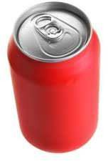

x60

4/21 Estimate measures - continued  - Mass  this apple weighs 125g  this bag of sugar weighs 1kg |  | 4/22 12- and 24-hour clock  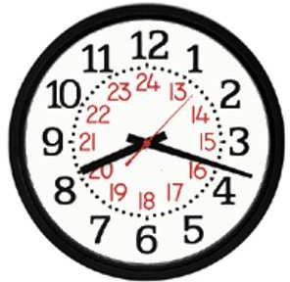  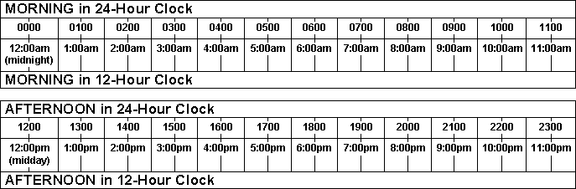
- Length | this man weighs 70kg  this pencil is 17cm long  length of classroom is 10m  distance to Exeter is 64miles | 4/23 – Properties of quadrilaterals & triangles
- Length |  | TRIANGLES – angles add up to 180⁰  Isosceles triangle  - 2 equal sides  - 2 equal angles  - 1 line of symmetry  - No rotational symmetry
- Length |  | Equilateral triangle  - 3 equal sides  - 3 equal angles - 60⁰  - 3 lines of symmetry  - Rotational symmetry order 3
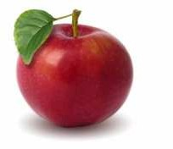

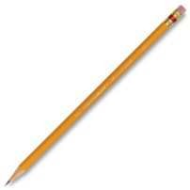

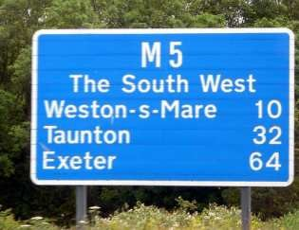

QUADRILATERALS – all angles add up to 360⁰  Square  - 4 equal sides  - 4 equal angles - 90⁰  - 4 lines of symmetry  - Rotational symmetry order 4  Rectangle  - Opposite sides equal  - 4 equal angles - 90⁰  - 2 lines of symmetry  - Rotational symmetry order 2  Parallelogram  - Opposite sides parallel  - Opposite angles equal  - NO lines of symmetry  - Rotational symmetry order 2  Rhombus (like a diamond)  - Opposite sides parallel  - Opposite angles equal  - 2 lines of symmetry  - Rotational symmetry order 2 | 4/23 – Properties of quadrilaterals & Triangles (continued)  Trapezium  - ONE pair opposite sides parallel  Kite  - One pair of opposite angles equal  - 2 pairs of adjacent sides equal  - ONE line of symmetry  - No rotational symmetry
4/24 Types of angles

Acute Right Obtuse
(less than 90⁰) (Exactly 90⁰) (Between 90⁰ & 180⁰)


Straight line
(180⁰ or two right angles)



4/25 Identify lines of symmetry

  - Horizontal line of symmetry
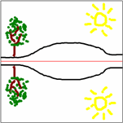

  - Vertical line of symmetry
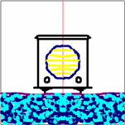

  - Oblique line of symmetry


  - Horizontal, Vertical & Oblique lines of symmetry

4/26 Complete a symmetrical figure
  - Tracing paper is brilliant for this
Example

4/27 Describe position of points
  - The horizontal axis is the x-axis
  - The vertical axis is called the y-axis
  - The origin is where the axes meet
  - A point is described by two numbers The 1st number is off the x-axis The 2nd number is off the y-axis
y
P
5
4
3
2
1

0 1 2 3 4 5 6 x
Origin (0,0) P is (5, 3)

4/27 Describe movement of shapes  y 5  4 A  3  2 B  1  0 1 2 3 4 5 6 x  Shape A has been moved 3 squares right and 2 down. This movement is called TRANSLATION | 4/29 Present discrete & continuous data  Continuous data is measured  e.g. heights, times, temperature  Graph to show a patient’s temperature over 24h  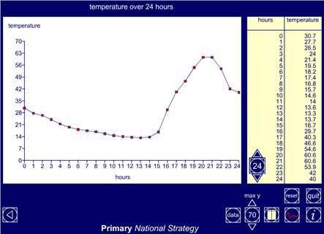
4/28 Complete a 2D shape
Example: Draw on lines to complete parallelogram
y
5
4
3
2
1
0 1 2 3 4 5 6 x
4/30 Compare data in graphs

‘Sum’ or ‘total’ means ‘add up’
‘Difference’ or ‘how many more’ means ‘subtract’

Bar chart to show Number of Ice Creams sold in a week

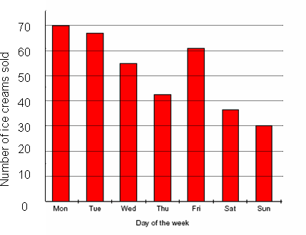
- What is the total number of ice creams
sold over the weekend?
Answer: 37 + 30 = 67
- How many more were sold on Friday than Saturday?
Answer: 61 – 37 = 24
4/29 Present discrete & continuous data

Discrete data is counted
e.g. cars, students, animals

Graph to show favourite colours in Class 4

8
6
Frequency
4
2
0 Red Blue Yellow Green Colours

Pictogram to show the number of pizzas eaten by four friends in the past month:



Alan 

Bob  
Chris      Dave   
- What is the sum of the number of pizzas eaten in the month
Answer: 6 + 9 + 19 + 12 = 46
- Find the difference in the number eaten by Chris and Bob
Answer: 19 – 9 = 10

