3/2 Recognise place value
352 means 300 + 50 + 2

3/3 Numbers in words and figures
In order to put FIGURES into WORDS, we must try to imagine that the number is in a PLACE VALUE table like this one
3/3 Compare and order numbers
- Write numbers lining up the digits
- Begin at the hundreds and compare 632 is the biggest
- Move to the tens and compare
Order is: 632, 176, 162, 147
Stage 3 PROMPT sheet

3/1 Count in multiples
hundreds | tens | ones
3 | 5 | 2

Now you must learn these multiples
Multiples of 4 | Multiples of 8 | Multiples of 50 | Multiples of 100
0 | 0 | 0 | 0
4 | 8 | 50 | 100
8 | 16 | 100 | 200
12 | 24 | 150 | 300
16 | 32 | 200 | 400
20 | 40 | 250 | 500
24 | 48 | 300 | 600
28 | 56 | 350 | 700
32 | 64 | 400 | 800
36 | 72 | 450 | 900
40 | 80 | 500 | 1000

Hundred | Ten | Ones
1 | 4 | 7
One hundred | forty | seven
One hundred and forty-seven

- To find 10 more or 10 less, it is the ‘tens digit’ that changes 10 more than 352 becomes 362
10 less than 352 becomes 342
hundreds | tens | units
3 | 5 | 2

Hundred | Ten | Ones
4 | 0 | 9
Four hundred |  | nine
Four hundred and nine

hundreds | tens | ones
3 | 5 | 2

Hundred | Ten | Ones
1 | 4 | 7
6 | 3 | 2
1 | 7 | 6
1 | 6 | 2

Hundred |  | Ten | Ones
1 |  | 4 | 7
 | 6 | 3 | 2
1 |  | 7 | 6
1 |  | 6 | 2

- To find 100 more or 100 less, it is the ‘hundreds’ digit that changes 100 more than 352 becomes 452
100 less than 352 becomes 252

3/4 Estimating

- Eyeball estimate
Here are 10 stars


Use this to estimate larger quantities

- Estimate by sampling Count your pulse over 15seconds
Multiply the number of pulses by 4 to get the pulse rate over 1 minute (15 x 4 = 60seconds)

- Estimate on a number line
Fill in the half way number first Then split up the half with the arrow
17
10 20

15 16 17 18 19

73
0
100
50 60 70 80 90
- Estimate by rounding off a number
To make a sum easier and give a rough answer

Example: 28 could be rounded to 30
£1.95 could be rounded to £2

3/5 Solve problems by estimating
3/6 Add 3 digit numbers mentally
Partitioning
236 + 319

200 + 30 + 6 + 300 + 10 + 9
= 500 + 40 + 15

= 555

Subtract 3 digit numbers mentally
363 - 126
Partitioning Counting on from 126

363 – 100 – 20 – 6 (126) + 4
=263 – 20 – 6 130 + 3

=243-6 133 + 230
=237 =363

Answer = 237

3/7 Written method for addition
- Line up the digits in the correct columns
  - 132 + 239 H T U 1 3 2 2 3₁ 9 + 3 7 1

Written method for subtraction


Example: Estimate the cost of 5 magazines at £1.95 each

Answer: It is about 5 x £2 = £10
Example: When full this bottle holds 400ml. Estimate how much water is left in this bottle.
    - Line up the digits in the correct columns
  - 327 - 119 H T U 3 ¹2 ¹7
1 1 9 -

2 0 8

400ml

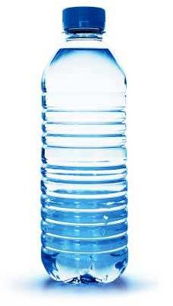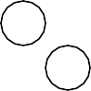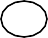
Answer: about 150ml
.............?

3/8 Estimate answers to calculations
- Round off each number
- Then do the calculation
- Check using the inverse

Example: Estimate 83 – 28

80 – 30 = 50
Inverse: 50 + 30 = 80

3/9 Missing number problems
Fact family for +/-

34 + 23 = 57 57 - 23 = 34

23 + 34 = 57 57 – 34 = 23

3/10 Know the 3, 4 and 8 times tables
 | 1 | x | 3 | = | 3 |  | 1 | x | 4 | = | 4 |  | 1 | x | 8 | = | 8
 | 2 | x | 3 | = | 6 |  | 2 | x | 4 | = | 8 |  | 2 | x | 8 | = | 16
 | 3 | x | 3 | = | 9 |  | 3 | x | 4 | = | 12 |  | 3 | x | 8 | = | 24
 | 4 | x | 3 | = | 12 |  | 4 | x | 4 | = | 16 |  | 4 | x | 8 | = | 32
 | 5 | x | 3 | = | 15 |  | 5 | x | 4 | = | 20 |  | 5 | x | 8 | = | 40
 | 6 | x | 3 | = | 18 |  | 6 | x | 4 | = | 24 |  | 6 | x | 8 | = | 48
 | 7 | x | 3 | = | 21 |  | 7 | x | 4 | = | 28 |  | 7 | x | 8 | = | 56
 | 8 | x | 3 | = | 24 |  | 8 | x | 4 | = | 32 |  | 8 | x | 8 | = | 64
 | 9 | x | 3 | = | 27 |  | 9 | x | 4 | = | 36 |  | 9 | x | 8 | = | 72
 | 10 | x | 3 | = | 30 |  | 10 | x | 4 | = | 40 |  | 10 | x | 8 | = | 80
 | 11 | x | 3 | = | 33 |  | 11 | x | 4 | = | 44 |  | 11 | x | 8 | = | 88
 | 12 | x | 3 | = | 36 |  | 12 | x | 4 | = | 48 |  | 12 | x | 8 | = | 96
Fact family for x/÷

9 x 8 = 72 72 ÷ 9 = 8

8 x 9 = 72 72 ÷ 8 = 9

Grid method
30
8
3 90 24

90 + 24 = 114
Partitioning method
38 x 3
= 30 x3 + 8 x 3
= 90
= 114
+
24

3/11 Multiply & divide
    - A 2-digit number by a single digit

Column method
3 8
3 x
1 1 4
2

3/12 Multiply & divide
    - Look for connections between two sums
    - Remember the fact family for x/÷
x10
Example: 6 x 4 = 24 So 60 x 4 = 240
So 240 ÷ 4 = 60
x2
Example: 9 x 8 = 72 So 18 x 8 = 144
So 144 ÷ 8 = 18

3/13 Tenths
tens | oness | . | tenths
8 | 2 |  | 6

    - This represents 6 tenths = 6
10

Counting in tenths (continued)
- A whole one divided into 10 equal parts
3/14 Write a fraction of a number of object

- 1 ÷ 10 = 1 tenth or
1 0r 0.1
10



2 are blue and

5



3 are red
5

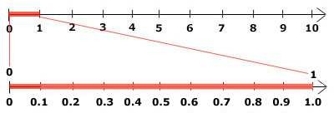
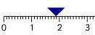3/15 Use fractions as numbers
A
B
C

1

To find

5
of 20 we do 20 ÷ 5 = 4

A – 0.8
B – 1.9
C – 2.6

- To find a tenth of an object or quantity you divide by 10
To find To find
- of 20 we do 4 x 2 = 8

5
- of 20 we do 4 x 3 = 12

5

Example:
1 of 20 = 20 ÷ 10 = 2
10

3/16 Equivalent fractions
  - The same fraction can be expressed in different ways

3/14 Fraction of line or objects
ALL THESE ARE 1
2

  - To find
1 of a line

5

Divide the line into 5 equal parts

Each part is 1

5
1 = 2 =

2 4

ALL THESE ARE 1

4
3 = 8

6 16

- To find
1 of a set of objects

5


Divide objects into 5 equal parts
1 = 2 = 3 = 6

4 8 12 24





Each part is 1
5

3/17 Add & subtract fractions

- To add and subtract fractions
When the denominators are the same
5 |  | 1 |  | 6
7 | + | 7 | = | 7
5 |  | 1 |  | 4
7 | - | 7 | = | 7

Do not add the denominators

Do not subtract the denominators

3/18 Compare fractions

- Fractions with the same denominator

3/19 Add & subtract measures
- The units must be the same
Length – Example

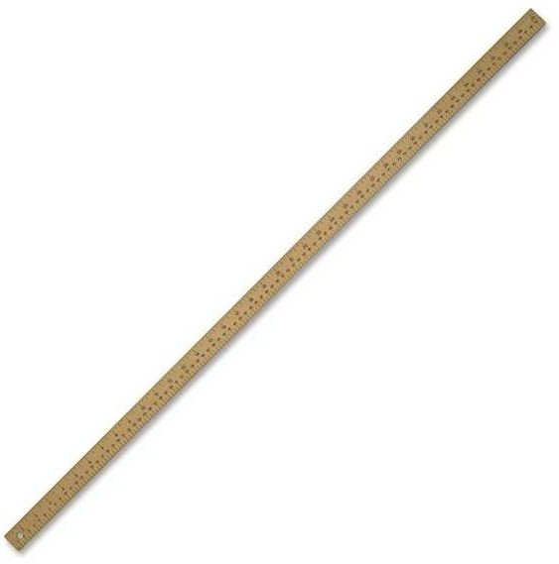
1metre = 100centimetres

1 3

10 10
7 9

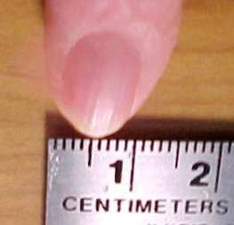10 10
1centimetre = 10millimetres

The bigger the numerator, the bigger the fraction

- Unit Fractions

1 1 1

2 3 6

The bigger the denominator, the smaller the fraction

3cm + 7mm
= 30mm + 7mm

= 37mm
or 3cm 7mm or 3.7cm
3cm 0.7cm
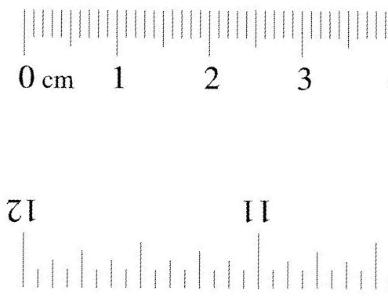
30mm
7mm

Mass – Example

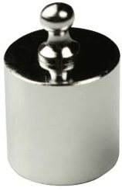
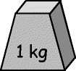 = 1000g

3kg – 450g
= 3000g – 450g

= 2550g
or 2kg 550g or 2.55kg

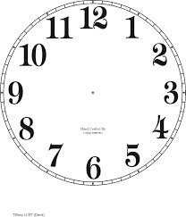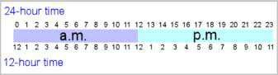3/19 Add & subtract measures (continued) Volume – Example
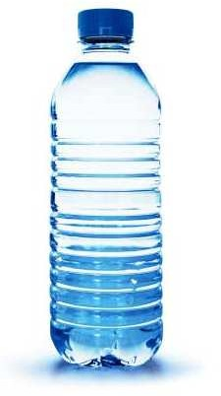
1litre = 1000millilitres

800ml + 720ml
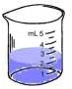
= 1520ml

= 1 litre and 520ml
= 1.52 litres

3/20 Perimeter

PERIMETER is the distance round the outside of a shape
- On a centimetre square grid – count round

Perimeter of this shape = 12cm

- Measurements given - add up all round

6cm

4cm 4cm

6cm
Perimeter of this shape = 6 + 4 + 6 + 4 = 20cm

3/21 Bills and change
To work out a bill
1 chocolate bar - £1.10 1 pen – 10p
1 pencil – 8p
Total = £1.28

To find change by the ‘add-on’ method

+2p +20p +50p = 72p

£1.28 £1.30 £1.50 £2.00

3/22 Time Analogue clock

Roman Hindu-Arabic
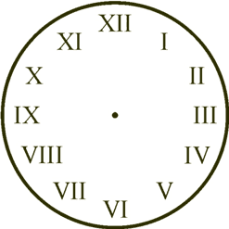

and 24-hour clock

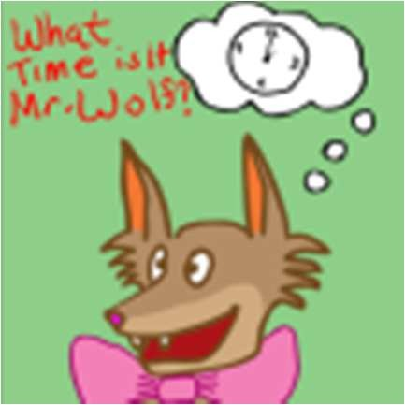
3/23 Time Reading the time

Months of the year
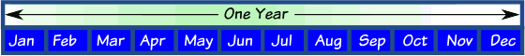

  - A rhyme to remember the days in each month

30 days has September, April, June and November. All the rest have 31 Except February alone, Which has 28 days clear And 29 in each leap year.
    - 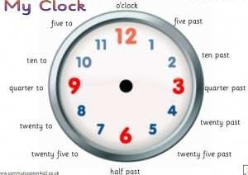the "knuckle method"


5 minutes between each number- so this time is 1:27 or we say 27 minutes past 1

Times of the day in 12-hour clock

Morning | Afternoon
12.00  midnight | 12.00  noon
1.00 am | 1.00 pm
2.00 am | 2.00 pm
3.00 am | 3.00 pm
4.00 am | 4.00 pm
5.00 am | 5.00 pm
6.00 am | 6.00 pm
7.00 am | 7.00 pm
8.00 am | 8.00 pm
9.00 am | 9.00 pm
10.00 am | 10.00 pm
11.00 am | 11.00 pm
12.00  noon | 12.00  midnight

3/24 Time – hours minutes, seconds

A knuckle is "31 days", and in between each knuckle it isn't.
And where your hands meet, the two knuckles are "July, August", which both have 31 days.

February has 28 days & 29 days in a leap year (every 4 years)

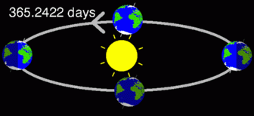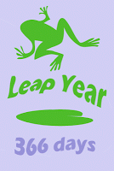Days in a year

- days in a year
- days in a leap year

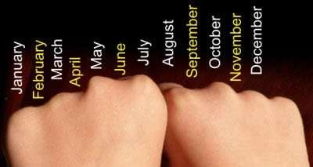
x60
hours
x60
min
÷60
÷60
sec

3/25 – 2D Shapes
  - With 3 sides (Triangles)
D
C
B
A

right-angled isosceles equilateral scalene

With 4 sides (Quadrilaterals)
E
D
C
B
A

square rectangle parallelogram trapezium rhombus

With 5 sides (Pentagons) With 6 sides (Hexagons)

regular irregular regular irregular 3/25 – 3D Shapes

Cube cuboid triangular prism cylinder sphere cone square-based
Pyramid
- Nets

3/26 Angle

  - An angle is an amount of turn
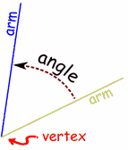

Angles in shapes Triangle - 3 angles

Quadrilateral - 4 angles

Pentagon – 5 angles

  - Names of angles

ACUTE angles are less than 90⁰

RIGHT angles are exactly 90⁰
3/27 Right angles
ONE right angle measures exactly 90⁰

TWO right angles measure exactly 180⁰ This is called a half-turn

THREE right angles measure exactly 270⁰ This is called three quarters of a turn

FOUR right angles measure exactly 360⁰ This is called a full or complete turn

90⁰ angle
A square for

To check if an angle is bigger or smaller than a right angle, use a square corner

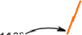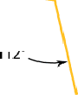OBTUSE angles are bigger than 90⁰

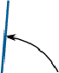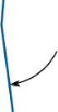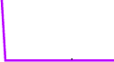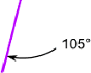This angle is greater This angle is less than a right angle than a right angle

3/28 Types of Lines


The Horizon is a horizontal line

3/29 Bar charts
Frequency table to show pets owned by Year 3

Type of pet | Tally | Number of pets
Dog | llll | 5
Cat | lll | 3
Rabbit | llll | 4
Fish | llll lll | 8
Hamster | ll | 2

A bar graph to show pets owned by Year 3
10

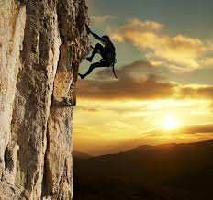8

Number of 6
children
4

2

0
Dog Cat Rabbit Fish Hamster
Type of pet

Pictogram to show the colours in a tube of Smarties

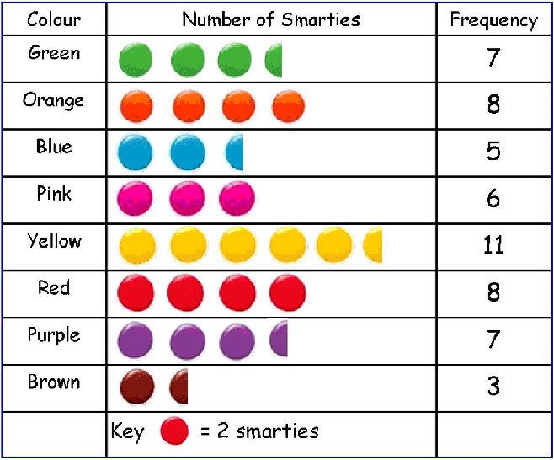This cliff face is a vertical line
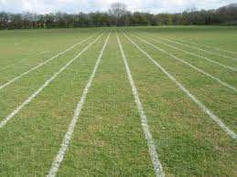
The running track is parallel lines (never meet)
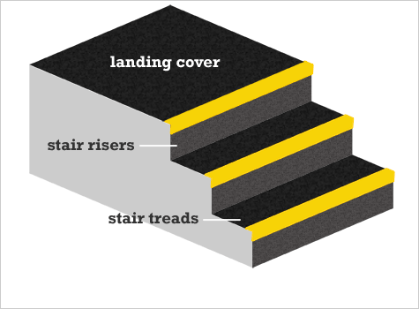

The rise & tread are perpendicular lines (meet
at 90⁰)

3/30 Solve answers to questions
  - Bar chart in 3/29

- How many more children own a rabbit than a hamster?
Answer: 4-2 = 2
- What is the difference between the number of children who own a dog and the number of children who own a cat?

Answer: 5 – 3 = 2
- How many pets are owned altogether by the children Year 3?

Answer: 5 + 3 + 4 + 8 + 2 = 22

Pictogram in 3/29

- How many fewer blue smarties are there than yellow ones?
Answer: 11 – 5 = 6

- Work out the total number of smarties in the tube
Answer: 55

