2/3 Estimate numbers
Stage 2 PROMPT sheet
- Eyeball estimate
Here are 3 sweets

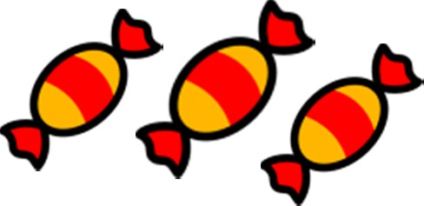

2/1 Know the 2, 3, 5, 10 times tables
0 | x | 2 | = | 0 |  | 0 | x | 5 | = | 0
1 | x | 2 | = | 2 |  | 1 | x | 5 | = | 5
2 | x | 2 | = | 4 |  | 2 | x | 5 | = | 10
3 | x | 2 | = | 6 |  | 3 | x | 5 | = | 15
4 | x | 2 | = | 8 |  | 4 | x | 5 | = | 20
5 | x | 2 | = | 10 |  | 5 | x | 5 | = | 25
6 | x | 2 | = | 12 |  | 6 | x | 5 | = | 30
7 | x | 2 | = | 14 |  | 7 | x | 5 | = | 35
8 | x | 2 | = | 16 |  | 8 | x | 5 | = | 40
9 | x | 2 | = | 18 |  | 9 | x | 5 | = | 45
10 | x | 2 | = | 20 |  | 10 | x | 5 | = | 50
11 | x | 2 | = | 22 |  | 11 | x | 5 | = | 55
12 | x | 2 | = | 24 |  | 12 | x | 5 | = | 60

Use this to estimate larger amounts

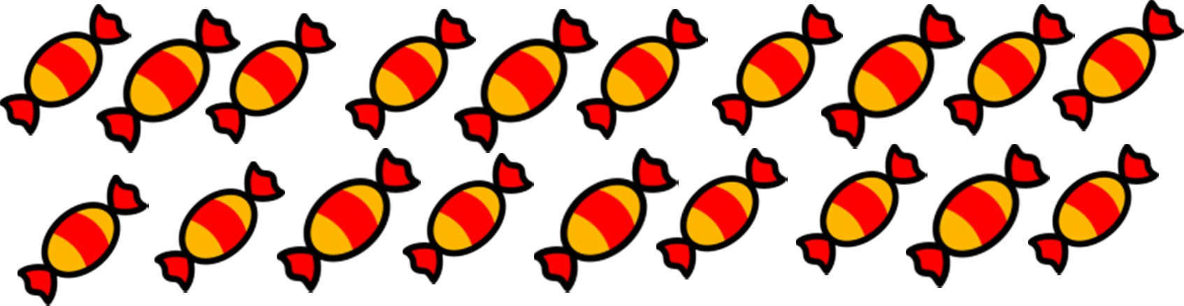
- Estimate on a number line

Fill in the half way number first Then split up the half with the arrow
7
0
10

5 6 7 8 9

11 12 13 14 15
12
10
20
0 x | 10 | = | 0 |  | 0 | x | 3 | = | 0
1 x | 10 | = | 10 |  | 1 | x | 3 | = | 3
2 x | 10 | = | 20 |  | 2 | x | 3 | = | 6
3 x | 10 | = | 30 |  | 3 | x | 3 | = | 9
4 x | 10 | = | 40 |  | 4 | x | 3 | = | 12
5 x | 10 | = | 50 |  | 5 | x | 3 | = | 15
6 x | 10 | = | 60 |  | 6 | x | 3 | = | 18
7 x | 10 | = | 70 |  | 7 | x | 3 | = | 21
8 x | 10 | = | 80 |  | 8 | x | 3 | = | 24
9 x | 10 | = | 90 |  | 9 | x | 3 | = | 27
10 x | 10 | = | 100 |  | 10 | x | 3 | = | 30
11 x | 10 | = | 110 |  | 11 | x | 3 | = | 33
12 x | 10 | = | 120 |  | 12 | x | 3 | = | 36

2/4 Order numbers

Ten | Ones
3 | 7
3 | 2
7 | 6
6 | 2

Count in 10s

tens | ones
3 | 7

Counting up in tens this digit changes:
37 47 57 67 77 87

2/2 Place value
tens | ones
2 | 8

28 means 2 tens and 8 ones (ones)
20 and 8

- Begin at the tens and compare 76 is the biggest
62 is next biggest

Ten |  | Ones
3 |  | 7
3 |  | 2
 | 6 | 2
 | 7 | 6
- Move to the ones and compare

Order is: 76 62 37 32

2/4 (continued) Inequality symbols  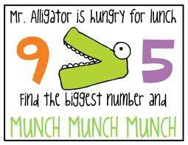  We say: 9 is bigger than 5 We write: 9 > 5  We say 5 is smaller than 9  We write: 5 < 9 | 2/7 Addition facts to 10                Addition facts to 20  Subtraction is the inverse of addition  + =  3 + 2 = 5  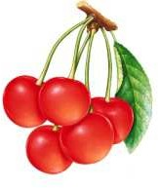 - 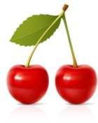 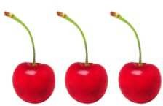  5 - 2 = 3  -  5 - 3 = 2
2/5 Numbers in figures and words
- one 11 eleven
- two 12 twelve
- three 13 thirteen
- four 14 fourteen
- five 15 fifteen
- six 16 sixteen
- seven 17 seventeen
- eight 18 eighteen
- nine 19 nineteen
- ten

- twenty 30 thirty
- twenty one 40 forty
- twenty two 50 fifty
- twenty three 60 sixty
- twenty four 70 seventy
- twenty five 80 eighty
- twenty six 90 ninety
- twenty seven 100 one hundred
- twenty eight
- twenty nine
2/6 Addition & subtraction problems
Words for ADD
altogether sum of total plus
Words for SUBTRACT
take away how many left? difference how many more? how many less?
 |  |  |  |  |  |  |  |  | 10
1 |  |  |  |  |  |  |  |  | 9
 | 2 |  |  |  |  |  |  |  | 8
 |  | 3 |  |  |  |  |  |  | 7
 |  |  | 4 |  |  |  |  |  | 6
 |  |  |  | 5 |  |  |  |  | 5
 |  |  |  |  | 6 |  |  |  | 4
 |  |  |  |  |  | 7 |  |  | 3
 |  |  |  |  |  |  | 8 |  | 2
 |  |  |  |  |  |  |  | 9 | 1

0 + 10 | 1 + 9 | 2 + 8 | 3 + 7 | 4 + 6
10 + 0 | 9 + 1 | 8 + 2 | 7 + 3 | 6 + 4
 |  | 5 + 5

10 + 10 | 11 + 9 | 12 + 8 | 13 + 7 | 14 + 6
15 + 5 | 16 + 4 | 17 + 3 | 18 + 2 | 19 + 1
 |  | 20 + 0

2/8 Add & subtract  = 28  20 + 8 = 28  20  8 +  28  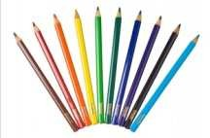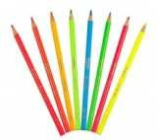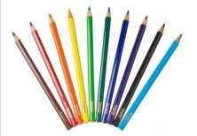  28 - 3 = 25  28  3 -  25  28 - 10 = 18  28  10 -  18  28 - 13 = 15  28  13 -  15 | 2/10 Add & subtact  Fact family for add and subtract  13 + 7 = 20  20 - 13 = 7 20 - 7 = 13
2/11 2, 5, 10 times tables

- See 2/1
Odds & even numbers
- Even numbers – can be paired up

Tip – the last digit always 0 2 4 6 8
- Odd numbers – cannot be paired up

Tip – the last digit always 1 3 5 7 9
2/12 Multiply & divide

Words for MULTIPLY
times product double triple

Words for DIVIDE
share split

Words for EQUALS
is gives

Fact family for multiply and divide
7 x 5 = 35

35 ÷ 5 = 7 35 ÷ 7 = 5
2/9 Add & subtact
7 + 3 = 10 is the same as 3 + 7 
10 – 7 = 3 is NOT the same as 7-10

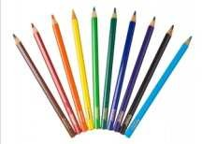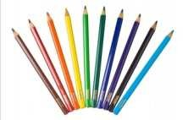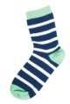

2/13 Multiply & divide  7 x 5 = 35 is the same as 5 x 7   35 ÷ 7 = 5 is NOT the same as 7÷35 | Repeated addition (Multiplication)
2/14 Multiply & divide  Example1: Here are 20 sweets to share Each child gets 5 sweets  How many children are there?  Divide them up into groups of 5 sweets-like this  There must be 4 children  Example2: Here are 12 marbles to share There are 4 children.  How many marbles does each get?  Divide them up into 4 groups - like this  Each child gets 3 marbles | Here are 3 footballers.  How many legs do they have altogether?  Addition sentence Multiplication sentence  2 + 2 + 2 = 6 3 x 2 = 6  Repeated addition is the same as multiplication
 |  | Addition sentence | Multiplication sentence
 |  | 5 + 5 + 5 + 5 = 20 | 4 x 5 = 20
 |  | 10 + 10 + 10 = 30 | 3 x 10 = 30
Repeated subtraction (Division)
Repeated subtraction is the same as division

This is the same as
15 ÷ 5 = 3

Because 5 has been
subtracted 3 times
to get to 0

15-5=10
10-5=5
5-5=0


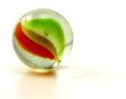
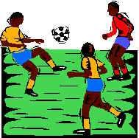


2/15 & 16 Fractions

To work out a half
Split into two equal parts

YES NO!!!!
2/17 Units of measure METRIC units of length are: Millimetre (mm)

Centimetre (cm) Metre (m) Kilometre (km)

2cm = 20mm 4.5cm = 45mm
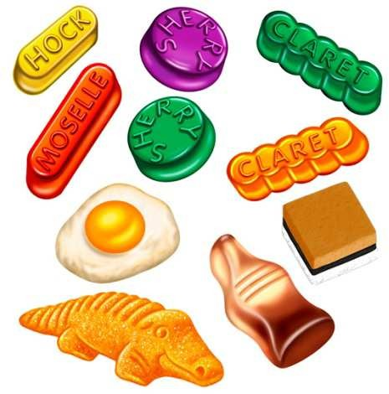1cm = 10mm
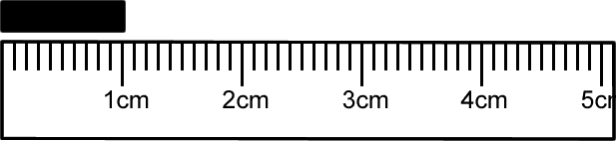

10sweets ÷ 2 = 5sweets OR 1 of 10 = 10 ÷ 2 = 5
2

To work out a quarter
Split into four equal parts

A big stride is about a metre

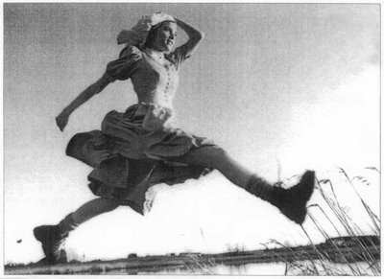
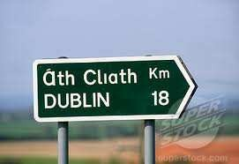
- Distance to Dublin is measured in kilometres

METRIC units of mass are:

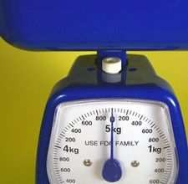
Gram (g) Kilogram (kg)

1 kilogram(kg) = 1000grams(g)
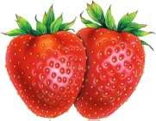

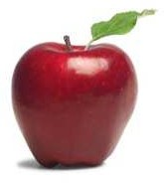
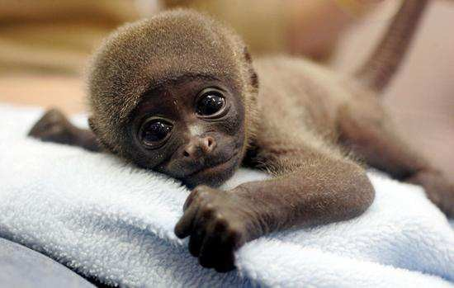
- An apple weighs 150grams

8 strawberries ÷ 4 = 2 strawberries
2
4 = 2
1
OR 1 of 8 = 8 ÷ 4 = 2
4

Baby chimp weighs 3kg

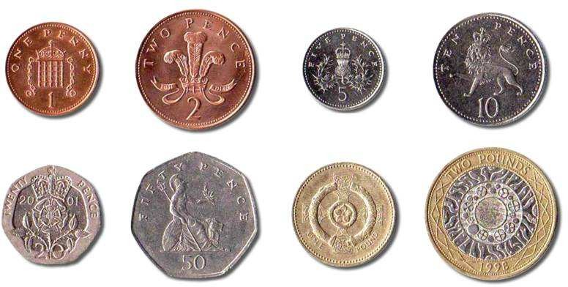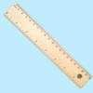2/17 Units of measure (continued) METRIC Units of capacity (liquids) are: Millilitre (ml)

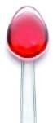
Centilitre (cl) Litre (l)
  - A medicine spoon holds 5ml


A 5-litre bucket

  - Fuel for the car is measured in litres

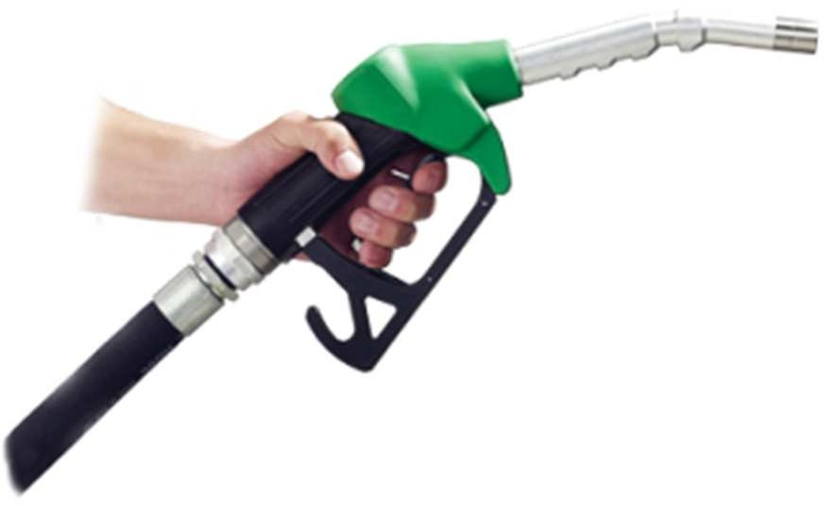

2/18 Compare units of measure

Think of the units of mass then order:
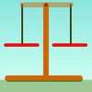
a bar of chocolate your teacher
a blown-up balloon a loaf of bread
A blown-up balloon < a bar of chocolate < a loaf of bread < your teacher

Think of the units of length used then order:
How high you could jump in the air How far you can kick a football How far you can run in ½ minute Length of a bug

Length of a bug < you could jump in the air < you can kick a football < you can run in half a minute

2/19 Money
To write amounts of money
£3 or £3.00 50p or £0.50
£3.50 or 350p BUT never £3.50p or £3.5 Value of coins

1p or £0.01 2p or £0.02 5p or £0.05 10p or £0.10 20p or £0.20 50p or £0.50 £1 or £1.00 £2 or £2.00

2/20 Bills and change
To add amounts of money 24p + 32p
=20p + 4p + 30p + 2p
=20p + 30p + 4p + 2p
=50p + 6p
=56p

To find change from £1

Subtraction method
£1 – 56p
= £1 – 50p – 6p
= 50p – 6p
= 44p
Add-on method 56p + 4p = 60p 60p + 40p = £1
= 4p + 40p
= 44p

2/21 Sequence of time
Smallest Second(s) 60
Minute(min) 60
Hour(h)
Day 24
Week 7
Month 4
Largest Year 12

2/22 Write time  The time shown is:  5 past 6 OR | 6:05 | corner | edge | face
2/22 Write time  The time shown is:  5 past 6 OR | 6:05 | 2/25 2D shapes on 3D shapes  6 6 faces – all rectangles  5 faces – 2 triangles  - 3 rectangles  3 faces – 2 circles  - 1 curved surface  2 faces – 1 circle  - 1 curved surface  5 faces – 1 rectangle  - 4 triangles
2/23 2D shapes
- 3 sides – Triangles
A vertical line of symmetry

equilateral isosceles
- 4 sides - Quadrilaterals

rectangle square parallelogram

trapezium kite rhombus
2/26 To sort 2D shapes and 3D shapes
Carroll diagram

Venn diagram
2/24 3D shapes  cube cylinder  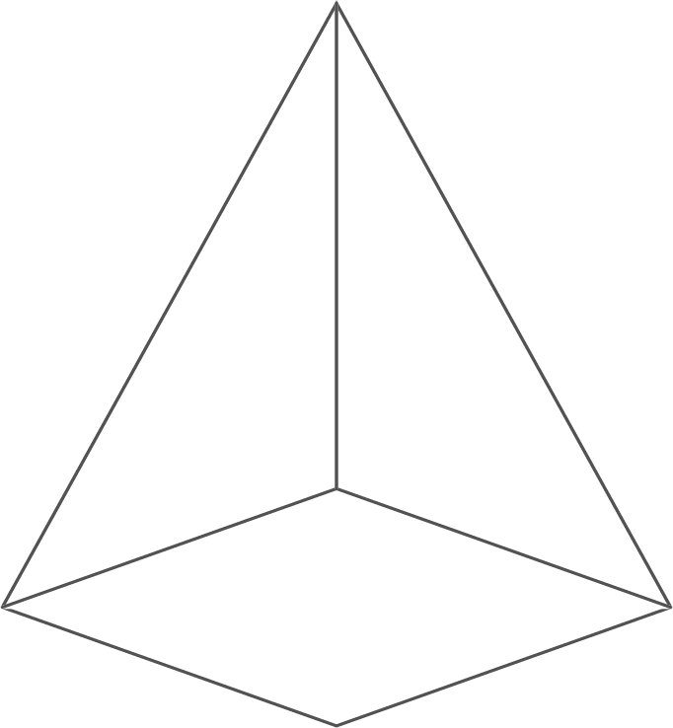  pyramid | cuboid  sphere
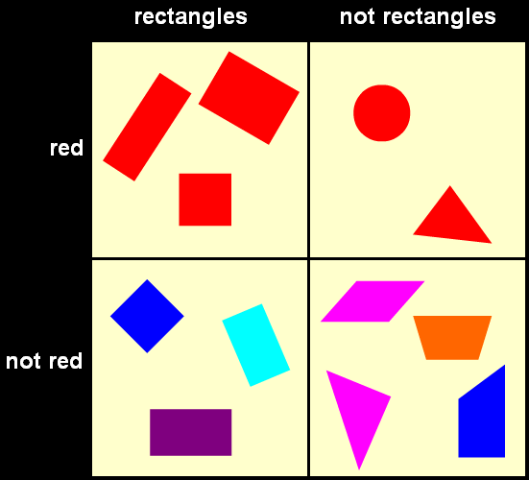
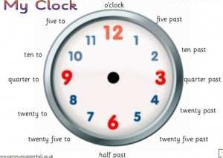
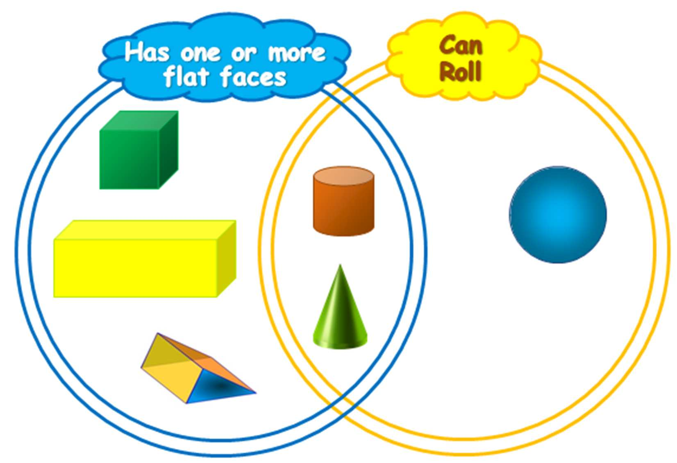

2/27 Sequence of shapes  Make these shapes into a pattern | Tally chart showing animals in the zoo  Block graph to show animals in the zoo
2/28 Describe position, direction & movement

LEFT RIGHT

ANTICLOCKWISE CLOCKWISE

Clockwise (1 right angle) or ¼ turn

Anticlockwise(1 right angle) or ¼ turn

Half turn (2 right angles)
 |  | 7
 |  | 6
 |  | 5
 |  | 4
 |  | 3
 |  | 2
 |  | 1
 |  |  |  | 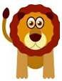 | 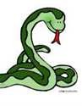 | 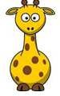 | 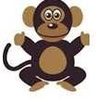
2/30 Questions about tables and graphs

Example:
Questions about ‘Animals in the zoo’

- How many animals are there altogether?
4+3+6+2+7=22
- How many more monkeys are there than lions?
7-3=4
- What animal is there least of?
giraffe
2/29 Tables and graphs

Pictogram of Year 2 favourite fruits
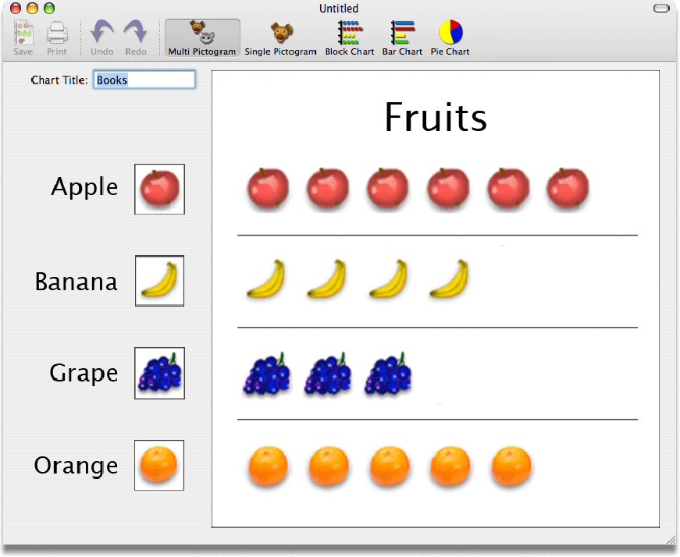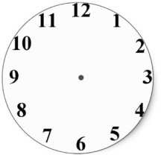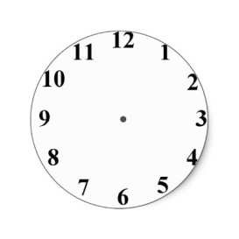
Animal | Tally | Number of animals
Penguin | llll | 4
Lion | lll | 3
Snake | llll l | 6
Giraffe | ll | 2
Monkey | llll ll | 7

