Year 1 PROMPT sheet  1/1 Count to 100 | 1/3 One more or less  1 less than 1 more than
Year 1 PROMPT sheet  1/1 Count to 100 | 1/4 Numbers as objects  Max has  Ann has  Max has MORE than Ann Max has the MOST  Ann has LESS than Max Ann has the LEAST
1/2 Count in twos

They are all EVEN
They all end in 0 or 2 or 4 or 6 or 8

1/2 Count in fives

They all end in 0 or 5 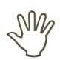
1/2 Count in 10s

They all end in 0 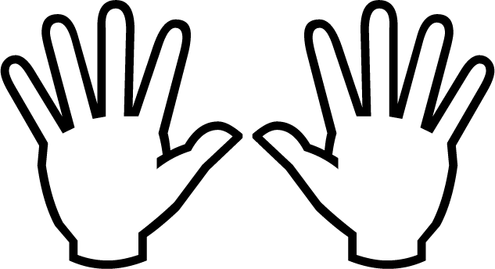
1/5 Numbers in figures and words

- one 11 eleven
- two 12 twelve
- three 13 thirteen
- four 14 fourteen
- five 15 fifteen
- six 16 sixteen
- seven 17 seventeen
- eight 18 eighteen
- nine 19 nineteen
- ten 20 twenty
1/6 Mathematical statements involving (+) (-) and (=)

We read: 3 added to 4 makes 7
We write: 3 + 4 = 7

We read: 7 subtract 3 makes 4
We write: 7 - 3 = 4
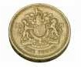
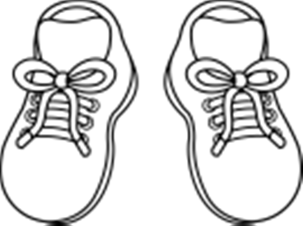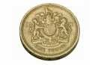
4 | 5 | 6

1 | 2 | 3 | 4 | 5 | 6 | 7 | 8 | 9 | 10
11 | 12 | 13 | 14 | 15 | 16 | 17 | 18 | 19 | 20
21 | 22 | 23 | 24 | 25 | 26 | 27 | 28 | 29 | 30
31 | 32 | 33 | 34 | 35 | 36 | 37 | 38 | 39 | 40
41 | 42 | 43 | 44 | 45 | 46 | 47 | 48 | 49 | 50
51 | 52 | 53 | 54 | 55 | 56 | 57 | 58 | 59 | 60
61 | 62 | 63 | 64 | 65 | 66 | 67 | 68 | 69 | 70
71 | 72 | 73 | 74 | 75 | 76 | 77 | 78 | 79 | 80
81 | 82 | 83 | 84 | 85 | 86 | 87 | 88 | 89 | 90
91 | 92 | 93 | 94 | 95 | 96 | 97 | 98 | 99 | 100

27 | 28 | 29

1 | 2 | 3 | 4 | 5 | 6 | 7 | 8 | 9 | 10
11 | 12 | 13 | 14 | 15 | 16 | 17 | 18 | 19 | 20
21 | 22 | 23 | 24 | 25 | 26 | 27 | 28 | 29 | 30
31 | 32 | 33 | 34 | 35 | 36 | 37 | 38 | 39 | 40
41 | 42 | 43 | 44 | 45 | 46 | 47 | 48 | 49 | 50

1 | 2 | 3 | 4 | 5 | 6 | 7 | 8 | 9 | 10
11 | 12 | 13 | 14 | 15 | 16 | 17 | 18 | 19 | 20
21 | 22 | 23 | 24 | 25 | 26 | 27 | 28 | 29 | 30
31 | 32 | 33 | 34 | 35 | 36 | 37 | 38 | 39 | 40
41 | 42 | 43 | 44 | 45 | 46 | 47 | 48 | 49 | 50

1 | 2 | 3 | 4 | 5 | 6 | 7 | 8 | 9 | 10
11 | 12 | 13 | 14 | 15 | 16 | 17 | 18 | 19 | 20
21 | 22 | 23 | 24 | 25 | 26 | 27 | 28 | 29 | 30
31 | 32 | 33 | 34 | 35 | 36 | 37 | 38 | 39 | 40
41 | 42 | 43 | 44 | 45 | 46 | 47 | 48 | 49 | 50

1/7 Number bonds |  | 1/8 Addition and subtraction Addition I need +2  Example: 8 + 6 to make  10  = 8 + 2 4  = 10 + 4  = 14  +  Subtraction I need -3  Example: 13 - 5 to make  10  13 - 3 2  = 10 - 2  = 8
1 + 9 = 10 OR | 9 + 1 = 10
10 – 1 = 9 OR | 10 – 9 = 1
2 + 8 = 10 OR | 8 + 2 = 10
10 – 2 = 8 OR | 10 – 8 = 2
3 + 7 = 10 OR | 7 + 3 = 10
10 – 3 = 7 OR | 10 – 7 = 3
   |  | 1/9 Addition & subtraction problems  3 balloons and 4 balloons make 7 balloons  + =  We can write: 3 + 4 = 7  7 balloons and 3 balloons burst leaves 4 balloons  - =  We can write: 7 - 3 = 4  NOTICE 7 - 3 = 4  3 + 4
4 + 6 = 10 OR | 6 + 4 = 10
10 – 4 = 6 OR | 10 – 6 = 4
5 + 5 = 10
10 – 5 = 5










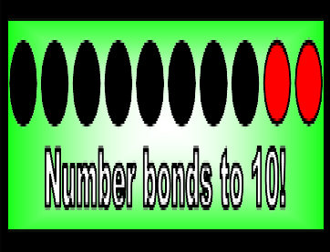
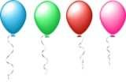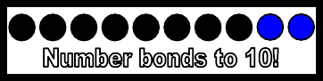

1/10 Multiplication and division  - A gardener sows some bean seeds  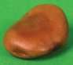  - How many seeds did he plant?  Answer: 3 x 5 = 15  or 5 x 3 = 15  - The gardener planted 15 seeds in 3 rows. How many seeds in each row?  Answer: 15 ÷ 3 = 5 | 1/12 Recognise and name a quarter  1  We write: 4  quarter of a rectangle  quarter of the balloons
1/13 Measures
- mass/weight

lighter

heavier
- capacity/volume

empty full less more
- time

slower faster
- length

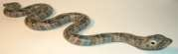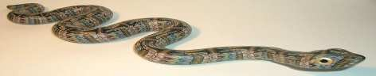
short long
1/11 Recognise and name a half
1
We write: 2
Split into two equal parts
1 1
2 YES 2 NO!!!!


Half of a rectangle

Half of the balloons
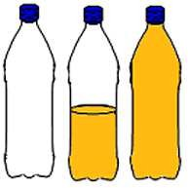
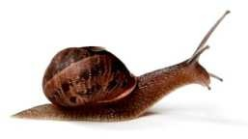
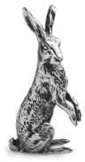
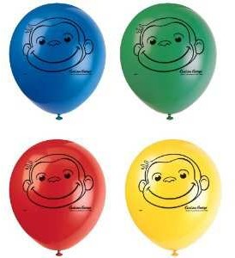

1/14 Measuring  - mass/weight  weight of an apple – grams | 1/15 Value of coins 1p 2p  20p 50p  1/15 Value of notes | 5p  £1 | 10p  £2
weight of a boy - kilograms | 1/15 Value of coins 1p 2p  20p 50p  1/15 Value of notes | 5p  £1 | 10p  £2
- capacity/volume medicine spoon - millilitres | 1/15 Value of coins 1p 2p  20p 50p  1/15 Value of notes | 5p  £1 | 10p  £2
bucket of water – litres | 1/15 Value of coins 1p 2p  20p 50p  1/15 Value of notes | 5p  £1 | 10p  £2
- time  count to 20 – seconds | 1/15 Value of coins 1p 2p  20p 50p  1/15 Value of notes | 5p  £1 | 10p  £2
eat your dinner – minutes | 1/15 Value of coins 1p 2p  20p 50p  1/15 Value of notes | 5p  £1 | 10p  £2
sleep - hours | 1/15 Value of coins 1p 2p  20p 50p  1/15 Value of notes | 5p  £1 | 10p  £2
- Length  A pencil – centimetres | 1/15 Value of coins 1p 2p  20p 50p  1/15 Value of notes | 5p  £1 | 10p  £2
The school hall – metres | 1/15 Value of coins 1p 2p  20p 50p  1/15 Value of notes | 5p  £1 | 10p  £2
Road distance– kilometres | 1/15 Value of coins 1p 2p  20p 50p  1/15 Value of notes | 5p  £1 | 10p  £2
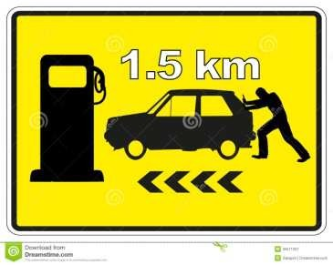 | 1/15 Value of coins 1p 2p  20p 50p  1/15 Value of notes | 5p  £1 | 10p  £2
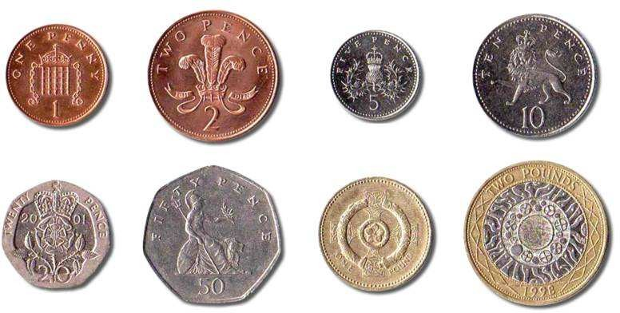
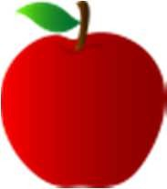

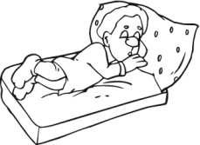
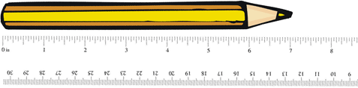
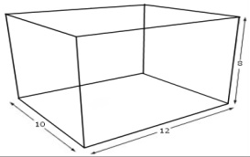
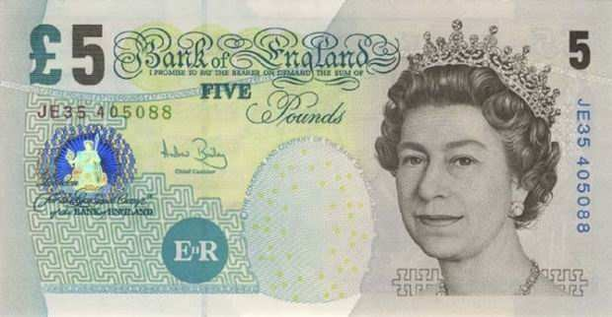
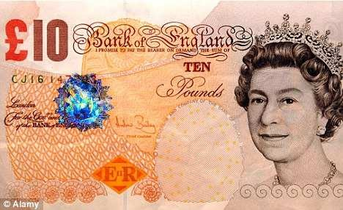
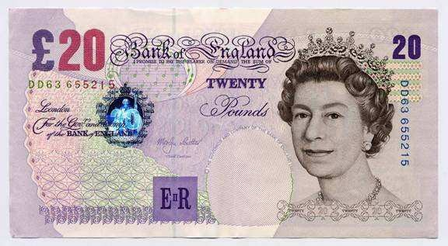
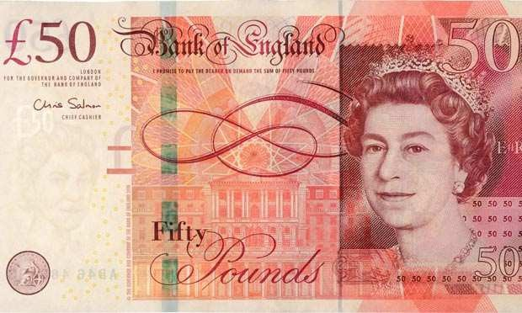
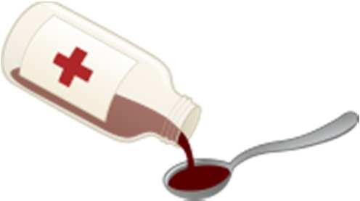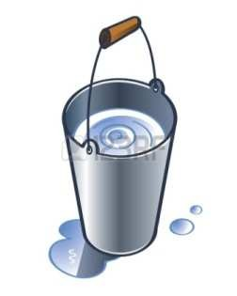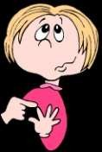

1/16 Sequence events  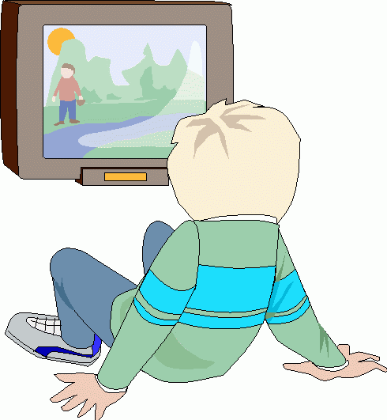  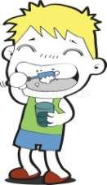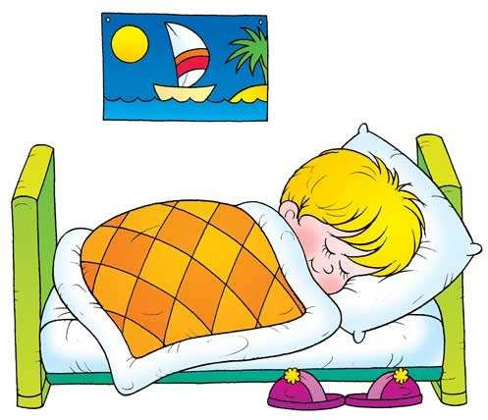  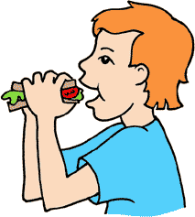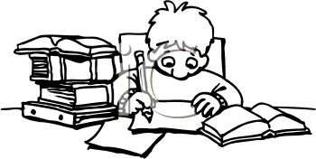 | 1/18 Tell the time  The long pointer is called the MINUTE hand. The short pointer is called the HOUR hand When the long pointer is on 12, we say o’clock  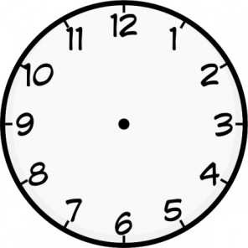  8 o’clock 3 o’clock  When the long pointer is on 6, we say ‘half past’  Half past 2 Half past 9
1/17 Dates  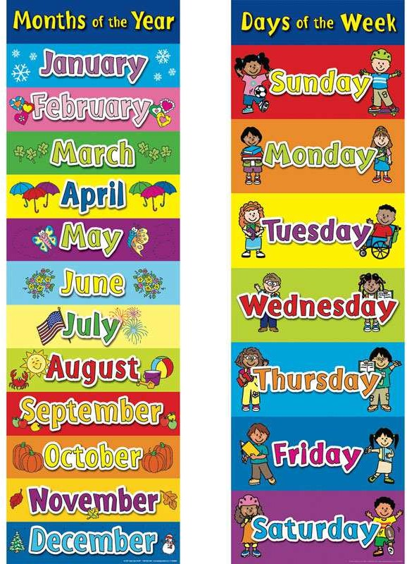  To write the date  Today is Thursday 3rd April 2014 | 1/19 Recognise 2D shapes  - Rectangle  - Square  - Triangle  - Circle
1. Watched some TV | 2. Came home from school
3. Brushed my teeth | 4. Went to bed
5. Had my tea | 6. Did my homework

1/19 Recognise 3D shapes  - Cuboid  - Cube  - Pyramid  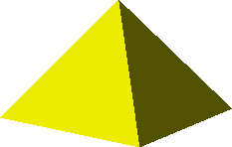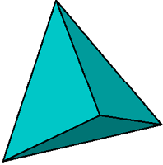  - Sphere | - Direction  Forward Backward Turn right Turn left  - Movement  ANTICLOCKWISE CLOCKWISE  Clockwise (1 right angle) or ¼ turn  Clockwise(2 right angles) or  ½ turn  Clockwise(3 right angles) or  ¾ turn
1/20 Position, direction and movement

- Position

What shape is above the cuboid?
Answer: circle What shape is below/under the blue triangle?
Answer: yellow triangle What shape is right of the green pentagon?
Answer: sphere
What shape is left of the circle?
Answer: square


